Evaluating High-Availability Strategies for Event Aggregation Layers in Cloud-Based Parcel Logistics Architectures

Robyn Doyle

M.Sc. in Computing in Cloud 2026


Department of Computing, ATU Donegal, Port Road, Letterkenny, Co. Donegal, Ireland.

Evaluating High-Availability Strategies for Event Aggregation Layers in Cloud-Based Parcel Logistics Architectures
Author: Robyn Doyle
Supervised by: Ruth G. Lennon

A thesis submitted in partial fulfilment of the requirements for the
Master of Science in Computing in Cloud

Submitted to Atlantic Technological University
Arna chur isteach chuig Ollscoil Teicneolaiochta an Atlantaigh May 2026

Declaration
I hereby certify that the material, which l now submit for assessment on the programmes of study leading to the award of Master of Science in Computing in Cloud, is entirely my own work and has not been taken from the work of others except to the extent that such work has been cited and acknowledged within the text of my own work. No portion of the work contained in this thesis has been submitted in support of an application for another degree or qualification to this or any other institution. I understand that it is my responsibility to ensure that I have adhered to ATU’s rules and regulations.
I hereby certify that the material on which I have relied on for the purpose of my assessment is not deemed as personal data under the GDPR Regulations. Personal data is any data from living people that can be identified. Any personal data used for the purpose of my assessment has been psudonymised and the data set and identifiers are not held by ATU. Alternatively, personal data has been anonymised in line with the Data Protection Commissioners Guidelines on Anonymisation.
I consent that my work will be held for the purposes of education assistance to future students and will be shared on the ATU Donegal (Computing) website (atucomputingdonegal.com) and Research THEA website (https://research.thea.ie/). I understand that documents once uploaded onto the website can be viewed throughout the world and not just in Ireland. Consent can be withdrawn for the publishing of material online by emailing Jade Lyons; Head of Department at Jade.Lyons@atu.ie to remove items from the ATU Donegal Computing website and by email emailing Denise McCaul; Systems Librarian at denise.mccaul@atu.ie to remove items from the Research THEA website. Material will continue to appear in printed formats once published and as websites are public medium, ATU cannot guarantee that the material has not been saved or downloaded.

Signature of Candidate Date

Acknowledgements

I would like to thank my wife and family for their constant support and encouragement during my study. I also want to thank my supervisor for their guidance throughout my work on this thesis.

Abstract
250 words at the end.

Acronyms

Acronym | Definition | Page
DDD  AKS  API  IT  HA  SPoF  CQRS  SoS  USO  TOGAF  ADM  REST  MSA  DevOps  CI/CD  EDA  CSPs  OS  SLAs  SDLC  ISO  IEC  SQuaRE  DB | Domain-Driven Design  Azure Kubernetes Service  Application Programming Interface  Information Technology  High Availability  Single Point of Failure  Command Query Responsibility Segregation  Systems-of-Systems  Universal Service Obligation  The Open Group Architecture Framework  Architecture Development Method  Representational State Transfer  Microservices Architecture  Developer Operations  Continuous Integration and Continuous Deployment  Event-Driven Architecture  Cloud Service Providers  Operating System  Service Level Agreement  Software Development Lifecycle  International Organisation for Standardisation  International Electrotechnical Commission  Systems and Software Quality Requirements and Evaluation  Database | ??  ??  ??  ??  ??  ??  ??  ?  ?  ?  ?  ?  ?  ?  ?  ?  ?  ?  ?  ?  ?  ?  ?  ?

Table of Contents

Declaration 4
Acknowledgements 6
Abstract 7
Acronyms 8
Table of Contents 9
Table of Figures 13
Table of Tables 14
Table of Code Listings 15
1. Introduction 1
1.1. Purpose 2
1.2. Aims 3
1.3. Objectives 3
1.4. Background & Technology of Interest 3
1.5. Problem Statement 5
1.6. Scope 6
1.7. Research Question 6
1.8. Contributions 6
1.9. Report Outline 7
1.10. Chapter 1 conclusion 7
2. Literature Review 8
2.1. Introduction 8
2.2. Problem Context 9
2.3. Digital Transformation and Enterprise Architecture 10
2.3.1. Digital Transformation in the Postal Sector 10
2.3.2. Enterprise Architecture for Digital Transformations 11
2.3.3. Domain Driven Enterprise 13
2.4. The transition from Monoliths to Domain Driven Microservices 14
2.4.1. Monolithic Architecture 14
2.4.2. Microservices Architecture 16
2.4.3. Domain Driven Design with Microservices 17
2.4.4. Migration Strategies 18
2.5. Event-Driven Architecture and Event Aggregation 19
2.5.1. Event Driven Architecture 20
2.5.2. Event Streaming Systems and fault tolerance 21
2.5.3. Event Aggregation 22
2.6. Cloud-Native Resilience, High Availability and Disaster Recovery 24
2.6.1. Cloud Computing 24
2.6.2. Cloud-Native Architecture 25
2.6.3. Cloud Resilience with Kubernetes 26
2.6.4. High Availability, Resilience and Disaster Recovery 27
2.7. Software Quality Standards 29
2.7.1. Software Quality Measurement 31
2.7.2. Reliability and Availability 32
2.8. Research Gap and Conclusion 32
3. Design 34
3.1. Design Overview 34
3.2. Functional, Quality and High Availability Requirements 35
3.2.1. Functional requirements. 35
3.2.2. Quality and High Availability Requirements 35
3.3. Baseline System Design 36
3.3.1. Scope and exclusions 37
3.3.2. Domain components and Event Flow 37
3.3.3. Aggregation and Materialised Read Model 42
3.4. High Availability Design 42
3.4.1. Pod Replication 46
3.4.2. Availability Zone Resilience 47
3.4.3. Multi-Region Resilience 48
3.4.4. Event Aggregation Service internal safeguards 50
3.5. Evaluation Metrics 52
3.6. Design Conclusion 53
4. Implementation 54
4.1. Implementation Overview 54
4.2. Event-Producing and Aggregation Microservices 55
4.3. Event Processing and Data-Integrity Implementation 56
4.4. Azure Kubernetes Service and Azure High Availability Deployment 57
4.5. Experimental Instrumentation and Monitoring 57
4.6. Implementation Conclusion 57
5. Test Strategy and Results and Analysis 57
6. Analysis 57
7. Conclusions 57
References i
Appendices ix
Appendix A: Code Listing x

Table of Figures

Figure 1 - TOGAF ADM Cycle 12
Figure 2 - Example of a tightly coupled parcel tracking monolithic architecture. 15
Figure 3 - Example of loosely coupled microservice architecture 17
Figure 4 - Strangler fig pattern. Adapted from (Microsoft, 2026c) 19
Figure 5 - Proposed Architecture for a Domain Driven, Event-Driven Parcel Tracking system. 22
Figure 6 - User interface view of all events 39
Figure 7 - User interface view of events for SHP-0001 40
Figure 8 - Baseline architecture 41
Figure 9 - Final High Availability Architecture 44
Figure 10 - Normal Operation 45
Figure 11 - Pod-Level Failover 46
Figure 12 - Availability Zone Failover 48
Figure 13 - Regional Failover 50
Figure 14 - Event Aggregation Service failover logic 51

Table of Tables

No table of figures entries found.

Table of Code Listings

Code Listing 1 MDBean Message Handling 16

- Introduction

In the postal sector there has been a steady move towards digitalisation (Samambet and Khouangvichit, 2025) which historically resulted in complicated monolith systems that had been repeatedly extended over the years. This led to a large amount of functionality being intertwined into single legacy applications that became inefficient, expensive to maintain and in some cases using technology that had run out of support. To avoid such a tight coupling of capabilities there was a critical need to extract this functionality into separately deployable microservices that would be easier to maintain and replace, leading to an enterprise of interconnected SoS. Since this functionality that the original monoliths provide need to remain continuously available it is common to replace them using the Strangler Fig pattern.
An example of this trend is visible in the postal sector where there has been a desire to implement event driven architectures (Florian Springer and Christoph Emmersberger, 2008) and behave as a communication backbone between the microservices of the SoS. This can be done by utilising technologies such as Apache Kafka (Kasaram, 2023) in line with a Domain-Driven Design (DDD) approach. These asynchronous communication systems are used to publish events as they occur in real time (Aung and Maw, 2017). These include when a parcel enters a logistics centre (Logistic Centre Domain) or when a parcel is delivered (Delivery Base Domain). Each domain publishes its events into a Kafka topic which is seen as a single source of truth for that event and stored in the cloud. All other domains interested in that event listen to this topic. Using the domain driven design approach the various IT systems responsible for producing these events are decoupled (Kasaram, 2023) and are only responsible for the data that they produce. This works well when domains want to read one event from a topic at a time.
However, what happens if the customer website (Customer Domain) needs to see all events relating to a shipment? An aggregation of events is required and that data needs to be searchable. This can be achieved by aggregating Kafka events and creating a GraphQL API with a PostgreSQL database that can then be called by the domains that require the data. The GraphQL API could run in the cloud, for example in a pod on a Kubernetes cluster running on Azure Kubernetes Service (AKS) and connected to an Azure hosted PostgreSQL database. However, by introducing this centralised aggregation layer in line with the Strangler Fig pattern, we now have a mission critical single point of failure (SPoF). If there is an issue with this API then the website, customer mobile applications and company branches are suddenly not able to query data relating to shipments. Therefore, there is an urgent need to provide resilience and redundancy for this cloud service. If the systems cannot query for the shipment data then the customers will not be able to use any of the services that they need for tracking of their shipments. This can lead to financial damage as well as long term reputational damage that could result in lost sales into the future. The longer the outage, the greater the damage would be. This outage can occur due to hardware, network or operational failures. In an era where cyber security risks have become more prevalent there is an increased risk that such a component can be attacked on purpose.

Purpose
The intention of this research is to determine a method that can mitigate a mission critical point of failure in cloud based event streaming aggregation services. These services are being utilised in a domain-driven system during a transition from monoliths towards SoS in large enterprises like those found in the postal sector. Can the decentralised benefits of event streaming and microservices be coupled with high availability without a major increase in complexity and cost? To aid the investigation various technical artifacts will be created. A set of microservices will be configured to act as the producers for a Kafka topic. These will run as containers in AKS. Then various different implementations will be created to demonstrate how high availability can be made possible for a consumer to aggregate the data and make it searchable via a GraphQL API using a PostgreSQL database. These various methods will be evaluated and benchmarked by using metrics including time, cost, complexity, reliability and availability. These empirical values will be benchmarked against the quality systems engineering requirements from the ISO/IEC 25000-70 standard. The overall goal is to discover an ideal trade-off where neither complexity or cost is too high or availability and reliability is too low.

Aims
- To evaluate high-availability methods for a cloud based event streaming aggregation service used in an organizational domain driven system.
- To investigate failover patterns for cloud microservices that provide minimal down time and minimal cost.

Objectives

- Review literature about cloud resilience, Kubernetes availability, event-driven architecture and domain-driven design.
- Deploy the SPoF components of the prototype using three different high availability setups;
- Localised pod replication and multi-node pool in one AKS cluster.
- Multi-cluster Kubernetes deployments following an active passive strategy.
- Geo redundant multi-cluster Kubernetes cluster deployment across two AKS clusters in different geographic locations using an active-passive and a n active-active strategy.
- Using the prototype to collect and compare metrics associated with each setup such as cost, availability, time for recovery, complexity for development and operations.

Background & Technology of Interest
The continuing demand for data and increased efficiency as well as an enhanced customer experience is leading postal enterprises to adopt event streaming as a preferred method for transferring data between services. Event data can be transmitted in an asynchronous manner which reduces complexity and waiting times. These organisations often have a large amount of legacy monolithic software that uses older types of API design such as Simple Object Access Protocol (SOAP). These setups are often inefficient and very complex, leading to slow performance and difficult development with multiple teams having ownership of parts of the same massive applications.

The solution is to split these monoliths into microservices , each of which is owned by one team or domain. These microservices would then publish and consume events from asynchronous interfaces such as Apache Kafka. This led to a largely decentralised and autonomous eco system where development could happen in an agile way with defined ownership. The architectural shift associated with this transition sets the enterprise up with an interconnected SoS and away from a centralised core. Since the postal sector provides critical services that should never go offline, the legacy monolith systems need to be incrementally dismantled using the Strangler Fig Pattern. This allows the new system to be built up in stages without any downtime of the actual service being provided to the customers.

However, this architectural transition introduces a new challenge, the fact that data sometimes still needs to be centralised. The aggregation of events makes this possible, but the clear bottleneck of a single aggregator becomes a critical SPoF. If this aggregation service fails then the business could suffer severe financial consequences, such as lost sales or penalties imposed by the regulator. Also, since this centralised aggregation service has a large number of domains depending on it, it is complicated to take offline for updates because consumers require around the clock access to the events. It is from here that this thesis aims to examine the possible approaches that could be taken to ensure that the service remains available to the consumers. The various infrastructure configurations will be evaluated against the fault-tolerance and high availability requirements outlined in the ISO/IEC 25000-70 standard.

The chosen cloud platform to host the microservices is Microsoft’s Azure cloud platform. The producer, aggregation and GraphQL applications will be written with Python and will provide a minimal functionality in order to represent the concept but without over-expanding the scope of this thesis. An Azure hosted PostgreSQL database will be utilised to implement the materialised read model for the GraphQL API. This allows for a Command Query Responsibility Segregation (CQRS) approach which separates the event producing services from the materialised read model used for the efficient querying. The event streaming capability will be provided using Azure Event Hubs by utilising its Kafka-compatible interface. The configured retention period within the Azure Event Hubs will determine how long shipment events are retained for. The materialised shipment state can be rebuilt, in the event of data loss, in the PostgreSQL DB by replaying the retained events. The retention period is a crucial setup parameter to determine how far back into the past data can be recovered for.

Problem Statement
Various ways exist to provide redundancy for a service in the cloud but there are many trade-offs related to them. Normally these solutions revolve around the concepts of backups, replica services, failover logic and automated network traffic rerouting. Picking the best strategy for a specific use case can be difficult, with the possible alternatives varying greatly in complexity and cost. During a transition away from monolithic structures and towards an orchestrated SoS is when the risk increases if a wrong setup is pursued. Engineering teams lack a framework to benchmark the infrastructure architecture decisions with internationally defined software quality metrics.

For a solution to effectively balance the decentralised nature of domain driven event streaming while providing a centralised endpoint for consuming systems to get the aggregated data requires a specialised approach. This approach should not be overly complex while also remaining affordable. It also needs to ensure that any updates to the API can be completed in a manner that does not cause downtime to the system. A further matter that must be considered is the indexing of the API, which may not be efficiently possible for a broad range of consumers with diverse requirements. The main issue is the critical logistics context there is an absence of an empirical evaluation comparing high availability cloud deployment techniques against standards such as those put forward by ISO/IEC 25000-70.

Scope
This dissertation will focus on achieving a highly available, application level architecture for an Event Aggregation Service and its GraphQL API. These services will be designed as microservices and will run inside an Azure Kubernetes Service cluster as containerised applications. Azure Event Hubs and a PostgreSQL DB will be provided and treated as supporting dependencies that are out of scope for the high availability experiments. The following evaluation will assume that those two dependencies are always available and will not be affected by failures at the Pod, Availability Zone or Azure Region levels.

Research Question
How can high availability be achieved for cloud-native event aggregation services in domain-driven postal enterprises, in line with the quality requirements of ISO/IEC 25000-70?

Contributions
The contribution of this thesis is a comparison of cloud-native architectures that aim to achieve high availability for an Event Aggregation Service within a domain-driven postal enterprise. This research evaluates different deployment strategies that provide progressive levels of redundancy and resilience. These strategies are designed to achieve high availability at the Pod, Availability Zone and Azure Region levels. Metrics will be collected to determine the availability, cost, recovery time, data correctness and complexity of the various solutions.

Report Outline
Chapter 2 contains a literature review which examines the body of knowledge for domain-driven design, event-driven architecture, microservice application architecture, cloud native high availability and software quality metrics, amongst other relevant topics. Chapter 3 introduces the baseline architecture design and the proposed highly available architectures to be implemented and evaluated. Chapter 4 describes the implementation of the prototype and its deployment within the Azure cloud environment. Chapter 5 provides details on the test strategy while chapter 6 delivers the results of the testing phase. Chapter 7 closes the thesis with a conclusion and focus on what further research can still be conducted.

Chapter 1 conclusion
This section outlined the problem that needs to be addressed and described the context in which it exists. It was used to orientate the research in the subject area and provide the direction for dissertation. The following chapters will include a Literature Review which will explore the body of knowledge that already exists in this research area as well as discussion on possible solutions to the research question.

- Literature Review
  - Introduction

Due to the rise of digital technology the postal sector has needed to adapt in order to remain competitive and retain customers (Otsetova, 2019). This has resulted in the constant adding on of features to business applications, a process which created large unwieldy monoliths. These monoliths became so complex that their functionality needed to be split into microservices. Such a large transformation needs to be performed carefully, otherwise enterprises risk failing to meet targets related to their business operations. Those failures can translate to fines imposed by regulators. A relevant example is the 10.5 million pounds fine handed to the Royal Mail in Britain for failing to uphold its delivery standards (Xu and Villiers, 2025). With better IT systems the performance of enterprises is enhanced, thus making it possible for targets to be met and to stay relevant in the market place (Angela Dawn Lawson, 2020).

Throughout this process of digitalisation, previous research highlights that postal services are creators of large datasets (Marsh and Piscioneri 2015), which can be utilised for the real time tracking of shipments. Enterprises are moving away from monolithic structures and towards event streaming systems in order to meet large scale data processing requirements (Ghosh, 2025). A study by Gartner from the year 2020 made a prediction that 80 percent of business applications in enterprises would need to process event data by the year 2025 (Kasaram, 2023). Apache Kafka arose as a popular event streaming technology due to its robust broker replication designed to avoid data loss (Kasaram, 2023). Data also needs to be available whenever systems require it. A trend towards unstaffed locker stations (Ilieva, Kolev and Gladchenko, 2024) is an example where zero downtime for access to shipment data at any hour of the day would be a prerequisite for successful operations within a postal service.

  - Problem Context
Enterprises in the postal sector are considered to be critical infrastructure that need to fulfil a Universal Service Obligation (USO) (Jovanović, Šarac and Čačić, 2025). At the same time the demands from customers have turned towards digital products and faster processing times, resulting in drastic changes affecting the postal sector (Jovanović, Šarac and Čačić, 2025). These changes create pressure to deliver more digitalised services. At some point the legacy monolith systems can no longer provide the functionality required. The target to shift towards Domain Driven microservices and event streaming solutions that run in the cloud has been adopted by enterprises (Zhong et al., 2024), however they often lack a clear plan to be able to provide high availability in line with software standards. For modern critical systems the entire chain needs to be kept online, a single critical issue can result in financial loss and reputational damage (Qi et al., 2023). However, this redundancy needs to be achievable within a realistic range for cost. A trade-off between the highest possible availability and the cost of the setup needs to be found so that an enterprise can gain the most advantage.
Despite associated costs, investing into fault tolerant and highly available systems is crucial. If such investment is avoided there could be significant risk to the long-term business model of the enterprise (Alyahya, Tipper and Babay, 2025). The technologies that make digital transformations possible at an affordable cost are centred on cloud solutions. Cloud based products, such as highly available container orchestration tools like Kubernetes, offer resilience and cost efficiency. The rapid rise of Kubernetes, which has become cemented in enterprises in less than a decade, has been due to its balance of operational benefits and innovative approach to high availability (Miyachi, 2021). This technology is now a standard for the deployment of modern microservice applications. Therefore, it is a key part of the problem context. Kubernetes, combined with Event Streaming technologies are becoming the backbone of how applications are being developed within a Domain Driven enterprise (Myllynen et al., 2023). However, to achieve high availability in this specific set up is a problem that has not been explored in detail.
  - Digital Transformation and Enterprise Architecture

    - Digital Transformation in the Postal Sector
When an enterprise needs to adapt to changing production requirements or consumer preferences, a need arises for structured change within the organisation (Sharavova et al., 2025). Digital transformations occur when information technology and its associated processes are integrated into organisations or updated to provide a renewed and more digitally integrated landscape. Such transformations can influence various parts of an enterprise including: products, management approaches, business processes and corporate culture (Tcukanova et al., 2022). Digital transformations have cyclically led to fundamental change in how people live their daily lives and how businesses operate (Platunina et al., 2025). For the postal sector specifically this has meant that they need to offer new services and products that reflect the growing mandate to connect citizens together, who increasingly prefer to communicate digitally (Otsetova, 2019).
Such undertakings are often complex and challenging, requiring good planning to be successful. For a transformation to be a “digital” transformation, some aspect of information technology needs to be involved. Examples can include a postal service moving away from sorting letters by hand and instead implementing an automated system that uses optical character recognition (OCR) that can analyse hand writing (Pallempati, Lakshmi and Das, 2024). Another example can be how a post service updates its legacy parcel tracking system, that initially updated shipment data once per day, with a real-time event driven tracking platform which allows customers to view regular updates in an app or website. Key players like Amazon are leading the way in how the traditional delivery space has been increasingly digitalised (Hassel and Sieker, 2022). The growth of Amazon’s market share in Europe highlights why digital transformations have become vital for the survival of the incumbent postal services, who either need to innovate and transform or risk losing out to new players (Samambet and Khouangvichit, 2025). Understanding why digital transformations occur is necessary before examining the enterprise architecture frameworks that organisations use to plan and govern such transformations.

    - Enterprise Architecture for Digital Transformations
Various frameworks have been established to support organisations in achieving successful digital transformations. Many of these are based on enterprise architecture which is an IT discipline focused on the translation of corporate strategy into day-to-day operations to improve timeliness, efficiency and reliability of business information (Costa and Brito, 2022). Its scope includes but is not limited to activities, workflows, people and processes which occur in the business (Costa and Brito, 2022). Enterprise Architecture frameworks like The Open Group Architecture Framework (TOGAF) were designed to support organisational transformations that allow an enterprise to adopt new trends in business and technology (The Open Group, 2022b). These frameworks provide structure to the processes that supports digital transformations.
The need for an Enterprise Architecture unit arises when an enterprise wants to change towards a new “target architecture” and away from a current “baseline architecture” . This change is often prompted by a desire to create or improve digital services and products. The implementation of these target architectures affects the underlying architecture at the business level, the application level, the data level and the technology level. In TOGAF there is an emphasis on gathering the requirements from the Business and mapping these to phases within the Architecture Development Method (ADM), as seen in Figure 1.

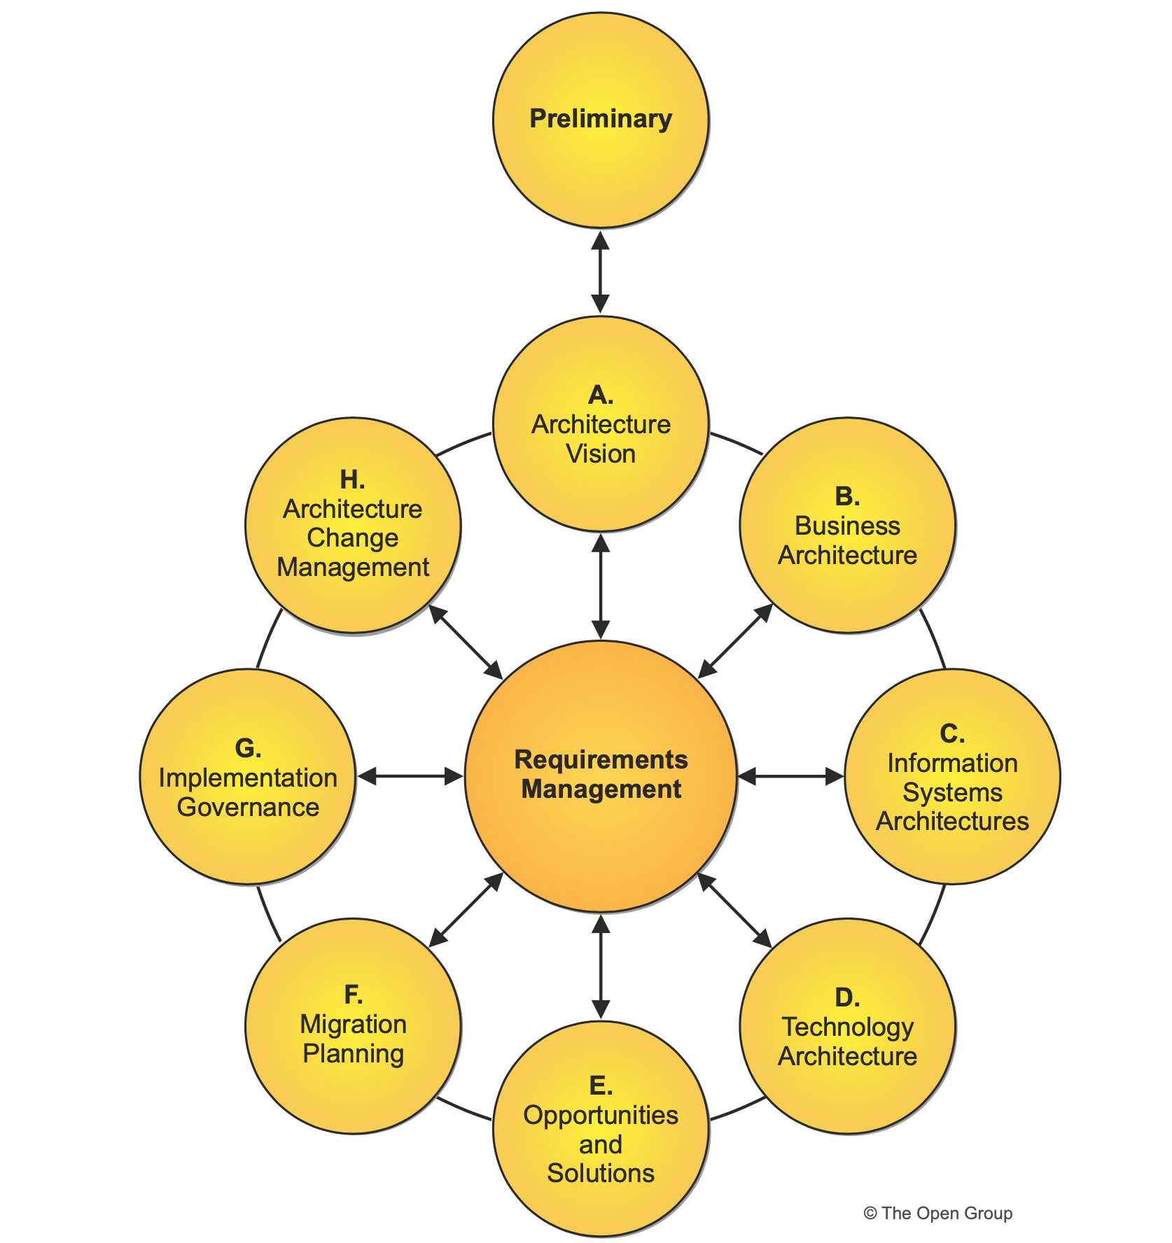
Figure 1 - TOGAF ADM Cycle

The core phases of the ADM are A to D, where requirements are gathered to create target architectures at specific layers. These target architectures are then used as a blueprint for the implementation teams that work on the work packages associated with the digital transformation program. The ADM is an iterative process where: a vision is established in phase A, architecture baselines and targets visualised in B to D, possible solutions identified in E, a roadmap for implementation developed at F, implementation governance carried out at G to oversee the transformation, and change management handled at H (The Open Group, 2022a). Having a structured framework in place is key in ensuring that a digital transformation has the best chance of success. It must be noted that many digital transformations fail due to the complexity of such initiatives and associated factors like budget overspending and milestones not being reached on schedule. Understanding how digital transformations are planned provides the baseline for examining how enterprises organise their business capabilities into domains to support resilient software architectures.
    - Domain Driven Enterprise
The idea of a Domain-Driven Enterprise revolves around organising business capabilities into bounded contexts, each representing a specific business domain. Within these bounded contexts, applications are often implemented as independently deployable microservices (Zhong et al., 2024). This bounded context is called an IT domain and is responsible for a specific IT capability within an enterprise. Each enterprise can decide how detailed their domains are. For a smaller organisation there might be a few core domains for IT applications used by groups such as “Finance”, “Human Resources” or “Accounting”. In a larger enterprise there normally is a need for sub domains in order to differentiate between finer core IT capabilities such as “Finance/Invoice Management”. For this research we can assume that a postal service has domains named “Logistics/Parcel Tracking”, “Logistics/Logistic Centre” and “Logistics/Delivery Base”. Each of these IT domains is managed by a specific IT team that manages the IT applications and operations for the unique bounded context.
This domain driven enterprise setup allows for ownership to be assigned to domain owners who are responsible for their specific business capability within the enterprise. These business capabilities can then be managed in a more focused manner. This avoids the scenario that multiple teams advance different ideologies for the same purpose in an unstructured manner. Thus, all of the core skills, knowledge and expertise for the business logic required to satisfy the customer of the domain are centralised within the domain (Hippchen et al., 2017). In this case domains can also be customers of other domains creating upstream and downstream relationships.
The following example is used, for the purposes of this work, to illustrate how a domain setup could be implemented. If a team working in the “Parcel Tracking” domain needs a reporting tool to visualise shipments they would send their requirements to the “Reporting and Analytics” domain owner. That domain owner and their team would take the data from an interface provided by the “Parcel Tracking” domain and prepare the dashboard and then hand it over. Operations and hosting of the dashboard as well as preparation of the data would all occur on the platform managed and owned by “Reporting and Analytics”. It is easy to see the value of only having one core Data and Reporting platform, rather than having multiple different platforms spread out across the enterprise. This expertise should belong to one domain and they should make the key decisions on how that capability is managed and advanced.
This leads to domain specific specifications being hidden and abstracted behind the domain boundary (Macías et al., 2023). Having established why enterprises design bounded domains we can now examine the transition from legacy monolithic applications towards modern domain-driven microservice architectures whose availability requirements must be met for both application and the infrastructure level.
  - The transition from Monoliths to Domain Driven Microservices
    - Monolithic Architecture
Software architecture is how IT applications are designed. The nature of the architecture can affect every aspect of the application including its functionality, reliability, scalability and associated costs (Mishra et al., 2022). Monolithic architecture is a specific kind of software architecture. It is a traditional method to develop applications where a single application houses multiple functionalities which many aspects of the business may rely on. This can include client and server side operations as well as interfaces, integrations layers, business logic and database layers (Mishra et al., 2022). Essentially a monolith cannot run its modules independently and is often deployed as a single application with tight coupling to other systems (Kiani et al., 2024).
A monolithic architecture can have advantages early in its lifetime when it has not become too complex, since it requires less deployments and can be worked on centrally. However, this tends to change as a large amount of functionality is often accumulated organically over years via add-ons and unplanned extensions. Therefore, the structure of a monolith tends to become more complicated and even chaotic, with software developers often only understanding certain parts that they are responsible for and not the overall application itself due to its complexity and size. Some of the key disadvantages that mature monolithic applications present include: the difficulty to make changes due to tight coupling, any update forces the entire application to be redeployed and if a single failure occurs within the system everything can stop working (Kiani et al., 2024). This tight coupling found in Monolithic applications, as seen in Figure 2, makes it difficult to achieve the resilience and scalability required by the enterprise. All functionality of the monolith is encompassed within a single deployment, which makes incremental changes difficult to implement and failures disproportionality impactful due to the dependencies.

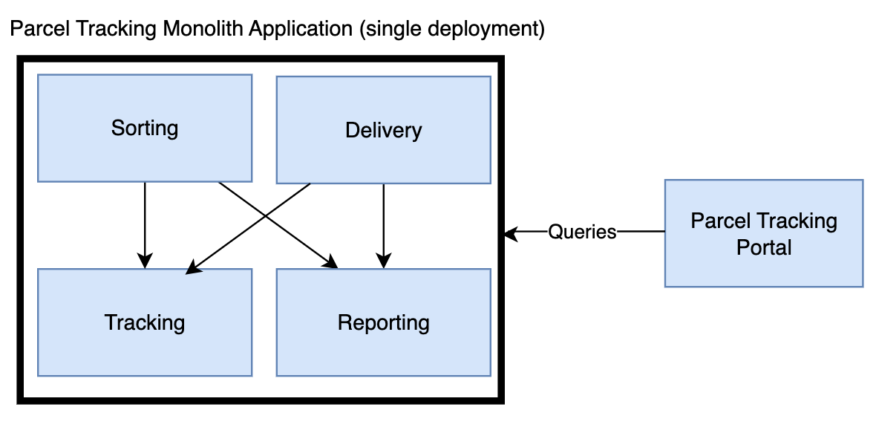
Figure 2 - Example of a tightly coupled parcel tracking monolithic architecture.
Aging monoliths using legacy software are also expensive with a high cost of ownership and maintenance (Ivanov and Tasheva, 2021). They often have poor performance and low speed which is felt by the end user, resulting in a bad customer experience which can lead to reputational damage and a loss of clients over time (Ivanov and Tasheva, 2021). In a fast changing environment the constant threat of hackers and malicious actors are also harder to defend against when using old and unsupported technology that is difficult to maintain (Ivanov and Tasheva, 2021). Thus, it is possible to understand why many enterprises feel the urgent need to transition away from Monolithic Architecture and towards an architecture that utilises Microservices.
    - Microservices Architecture
There has been a trend in enterprises to move towards Microservices Architecture (MSA) in order to enable the immediate modifications of business applications and reduce their complexity (Kiani et al., 2024). MSA allows applications to be deployed independently with fully self-contained services that allow for faster releases and improved maintainability and scalability (Oumoussa and Saidi, 2024). This architectural approach reflects principles found in the Unix philosophy where each program does only one thing and does it well (McIlroy, Pinson and Tague, 1978). Working with the code base becomes easier and ownership is more easily assignable (Kalske, Mäkitalo and Mikkonen, 2018). This simplifies work performed on each microservice, but can lead to more complex deployment operations, since multiple deployments, as seen in Figure 3, are now required where in the past one may have been sufficient (Zeng, Niu and Qiao, 2023). These independently deployable microservices can communicate via a common API Gateway, allowing for each service to have an individual connection to other systems.
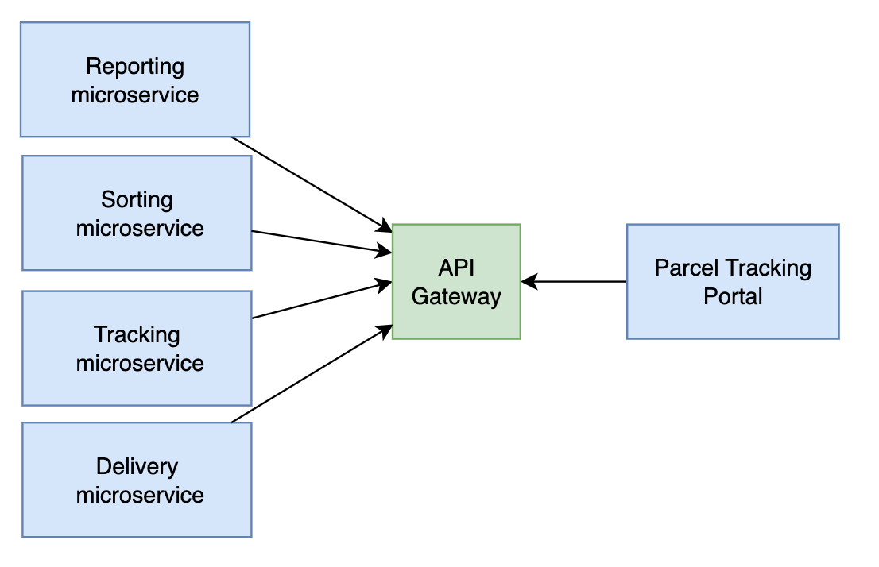
Figure 3 - Example of loosely coupled microservice architecture
Having more applications means more maintenance and higher operational overhead. A new approach for the deployment of the microservices evolved that focused on the containerisation of the applications (Zeng, Niu and Qiao, 2023). These containers can be quickly deployed using Developer Operations (DevOps) pipelines to container orchestration tools like Kubernetes. Continuous Integration and Continuous Deployment (CI/CD) pipelines are used for fully automated deployment of applications (Saxena et al., 2024). Such systems streamline the work on microservices and remove much of the overhead involved in the deployment and operations. Thus the effectiveness of MSA applications means they have many benefits in comparison to Monolithic applications. Understanding why the MSA method is an efficient approach for application development and deployment is crucial before examining how enterprises are utilising it in a Domain Driven context.

    - Domain Driven Design with Microservices
In a domain driven enterprise each domain has its own set of applications that are ideally set up as microservices performing one core function each. The microservices can then communicate with other systems by consuming interfaces provided by other microservices, including from other domains. If a domain depends on data or services from another domain, then it is considered to be downstream of that other domain. If it is providing data or services to another domain it is considered to be upstream of that other domain. A domain can be both upstream and downstream of other domains at the same time, depending on the nature of the data flow and dependencies (Evans, 2004). These integrations can be implemented with synchronous technologies like Representational State Transfer (REST), but it is often more efficient to use asynchronous set ups following Event Driven Design (EDD) (Myllynen et al., 2023).

The combination of microservices deployed in domains following DDD and integrated using EDD allows for modular development that creates a clear alignment between business objectives and technical architecture (Myllynen et al., 2023). When microservices are designed to perform one function for one domain and asynchronous communication is leveraged, a decoupling effect occurs. Applications do not need to directly wait for responses from other applications, increasing the availability of the services and reducing direct dependencies between services (Vural and Koyuncu, 2021). This creates a modern infrastructure that provides autonomy to teams and systems to develop at their own pace and reducing direct dependencies to other applications. When a domain needs data for its application it can read it from a topic within the Event Streaming platform where other domains have been producing events into. There is no direct request sent to other domains, reducing the coupling between applications. How EDD infrastructure can be implemented to support a resilient and highly available architecture will be further explored in this dissertation.

    - Migration Strategies
Companies around the world are working to migrate from monolithic applications towards microservice-based architectures in order to make the applications more scalable and easier to develop (Mishra et al., 2022). For businesses that cannot afford much or any down time this provides a difficult question. How to migrate away from the live Monolith which is currently still providing key services and move towards the new MSA system. If the service cannot be interrupted then a gradual migration can be considered. A technique known as the Strangler Pattern can be followed that allows for a gradual transition (Wolfart et al., 2021). This pattern is used to do an evolutionary rewrite of the application system while keeping the original application active in the process (Yoder and Merson, 2020). Since clients of the original monolith may need uninterrupted access to the functionality that the monolith provides, an API gateway can be used to route between the old system and new microservices that are gradually built up to replace sections of the monolith (Yoder and Merson, 2020). The API gateway acts as a façade. It is an abstraction technique that allows microservice to gradually replace the monolith while hiding these complexities. The transition can be an incremental approach where the monolith is decomposed piece by piece, with the possibility to fall back to the original monolith if the new microservice has any initial issues (Daya et al. 2021). See Figure 4 for a visual representation of the strangler fig pattern. This approach to transitioning away from monoliths and towards new microservice limits the downtime of the service in such an effective way that clients may not even notice anything at all. Migration strategies highlight how enterprises transition towards MSA but they do not explain how the newly introduced microservices communicate with each other in a more reliable and scalable way. For that we need to examine Event Driven Architecture in more detail.
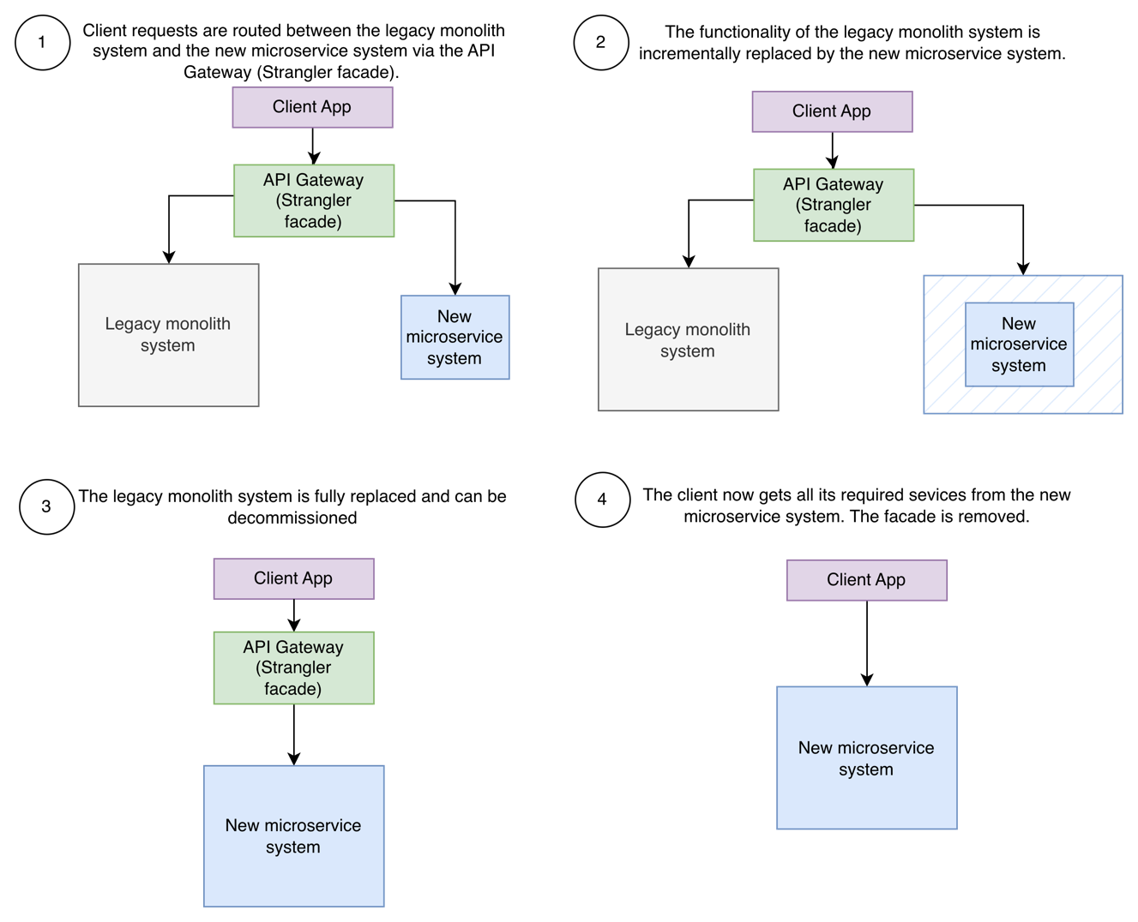
Figure 4 - Strangler fig pattern. Adapted from (Microsoft, 2026c)

  - Event-Driven Architecture and Event Aggregation
    - Event Driven Architecture
As soon as enterprises think about transitioning towards Domain Driven MSA the question of how these new services will communicate arises. Traditionally, microservices rely upon various application programming interfaces (API) types to send and receive data. Common API technologies include SOAP, REST, GraphQL and gRPC, which follow a traditional request-response architecture and are typically implemented synchronously, which force the sender and receiver to wait upon one another (Choudhary, 2025). For large scale domain driven enterprises there is a requirement for a more scalable option where the producer and consumer are not directly coupled (Laigner et al., 2024). Such an approach should positively influence the future development of the application as well as reduce the spread of failures and increase the stability of its components (Laigner et al., 2024).
Asynchronous methods like Event Streaming provide the foundation for scalable Event-Driven Architecture (EDA) where microservices produce and consume events into partitioned logs called topics (Choudhary, 2025). Events are data objects which represent notable occurrences or significant changes in state within the system (Karthik Reddy Thondalapally, 2025). These events are stored with a precise timestamp that records when the event occurred. Thus a chronological order of when an event occured can be established and used to build up a history. Producer and consumer applications of these events are independent and communicate without direct knowledge of how the other systems are implemented. This decoupling allows for improved scalability of the system and increased adaptability to changing business requirements (Karthik Reddy Thondalapally 2025).
In comparison to more traditional request-response architectures, where a sender communicates to a specific target, EDA systems typically implement a publish-subscribe pattern (Choudhary, 2025). This can provide reliable event delivery while maintaining event ordering within defined processing boundaries (Choudhary, 2025). Producers publish to immutable and centralised streams that multiple consuming applications can consume in real time (Ijsrset and Dr. Susheel Kumar Tiwari, 2024), without being directly connected to the producers. This means that more consumers can be added without any impact on producers and thus avoiding extra development effort. This makes EDA an attractive option when designing a modern, resilient and scalable enterprise architecture.
    - Event Streaming Systems and fault tolerance
EDA can be set up to be fault tolerant. Specific implementations of Event Streaming, such as Apache Kafka, are configured to store events in topics (Vyas, Tyagi and Sahu, 2023). These topics are partitioned and replicated across brokers which producer microservices write into and consumer microservices read out of (Ezzeddine et al., 2021). This configuration is increasingly becoming the backbone of modern enterprise event streaming setups (Prakasha et al., 2026). Even if a node fails, the data is available due to the replication feature. The consuming applications use offsets to determine how much of the topic has been consumed. The events are immutable and are persisted within the broker for a specified amount of time. This persistence can be configured to remain for months, depending on the requirements of the enterprise. If a failure occurs, the consumer can continue processing from the last committed offset once everything is online again.
If the consumer loses its local state, the history can be replayed simply by re-reading the data from the earliest available record, thus rebuilding the local state (Laigner et al., 2024). Being able to replay the data back into the consumer is efficient since the producing application that feeds the Kafka topic does not need to transmit historic data. The data is persisted within the broker which enables quick recovery and further improves what is already an inherently resilient system (Prakasha et al., 2026). Kafka also benefits from a fault-tolerant architecture where replicated partitions provide data availability during broker failures. The fault tolerant and decoupled nature of Event Streaming means that if a failure occurs in one consumer, it is much less likely to affect other consumers as they are isolated from each other and are independently responsible for creating their own local states from the events stored in the topic. This improves the resilience of a distributed microservice ecosystem and reduces the impact and blast radius that an incident would have on other applications. Despite this approach being quite effective for reading data from a single topic, a problem arises when downstream consumers require a consolidated view of events that originate from multiple topics and domains. Thus, there is a requirement for events to be aggregated and presented in a searchable format to the consumers.

    - Event Aggregation
The rise of modern event stream processing systems has been accompanied by a move towards the Dataflow model, where independently operating services communicate using immutable events that are stored across a distributed infrastructure (Gulisano and Margara, 2024). Despite this model allowing for scalable architecture and fault tolerant operations, consumers often need the data from the independent sources to be aggregated with data from other domains in order to provide real business value. This data needs to be provided in a consolidated view and should be searchable for other consumers. An example would be a Postal Service Customer App service required to present events from both the “Parcel Tracking” domain as well as others, like the “Delivery Base” domain, so that the end customer gets an end to end lifecycle of the journey of their parcel. Here the “Customer” domain would need to be able to query for all events that relate to a specific shipment and then display this in the User Interface of the Customer App. The proposed architecture can be seen in Figure 5.

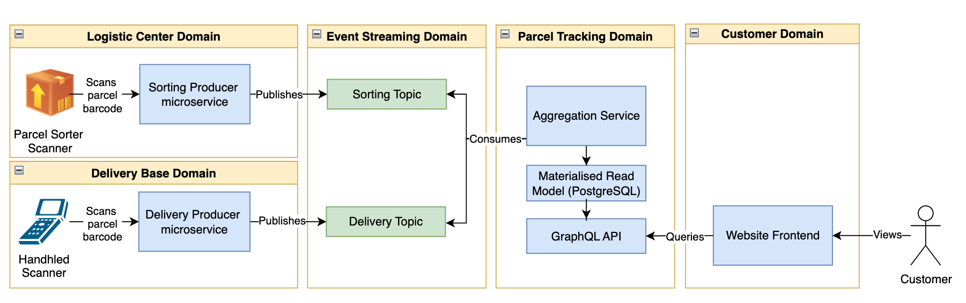
Figure 5 - Proposed Architecture for a Domain Driven, Event-Driven Parcel Tracking system.

In order to avoid the regular querying and matching of data from multiple event streams it is possible to build an aggregation service that is dedicated to building a unified view of the data from multiple topics and present it to downstream consumers for querying (Laigner et al., 2024). Within Command Query Responsibility Segregation (CQRS) architectures, these unified views are commonly implemented as materialised read models that are constantly updated when new events appear. The materialised view provides the current state of the shipment, allowing for queries like “Where is the parcel right now?” For example, the state of a parcel could be “In Distribution in Vienna, since 10:00, in Truck 55, driven by Driver 345”. This information is updated as soon as the underlying events arrive, making it an efficient way for consumers to understand the state of shipments within the system. In order to make this data quickly accessible for downstream consumers, it can be stored in a database such as PostgreSQL, where a materialised read model can provide efficient query access. An API interface, such as GraphQL or REST, is required to make the data accessible and abstract the complexity of the underlying event-driven system (Pan et al., 2024).
Despite the fact that an Event Aggregation Service efficiently consolidates data for downstream consumers, it presents architectural challenges. These include but are not limited to: the requirement to correctly process events that arrive out of order, replay persisted events to recover the state in the event of failures, and maintain consistency between the materialised read model and the event streams. A failure of the data store or the Event Aggregation Service itself could lead to downstream consumers being affected, even if the Event Streaming platform itself is operational. These challenges highlight that the success of the Event Aggregation Service lies not only in infrastructure resilience; true high availability requires a well-designed application-level architecture.
An Event Aggregation Service ensures that less effort is required by all consumers that require state information (Pan et al., 2024) about the specific entity that they are interested in. However, if many applications from many domains consume this aggregation service a clear SPoF materialises if no redundancy measures are prepared. Such an architectural weakness could affect the entire operation of the postal service. Scenarios that potentially could lead to major reputational and financial damage include but are not limited to: the customer app or website failing to load shipment data, the delivery agents failing to confirm deliveries, the customer support call centre failing to provide updates on the status of parcels. Even if all other producers and consumers within the event streaming system remain online, this single aggregation service would have a major impact upon the operations of the enterprise (Pan et al., 2024). Therefore, it is clear that although an aggregation of event data is extremely useful, it leads to mission-critical components becoming part of the system and presenting a SPoF if not configured carefully. It is important for an enterprise that an aggregation service of this nature is highly available in order to improve the resilience of the EDA.
  - Cloud-Native Resilience, High Availability and Disaster Recovery
    - Cloud Computing
The enterprises that choose to transition their monolithic applications towards a microservice architecture also need to consider where these new applications will run. To deploy them efficiently a scalable and modern solution is required. Traditionally applications were deployed on-premises using physical, dedicated servers that the enterprise would own and maintain with great expense and localised effort. Virtual machines could be used in order to make those servers more efficient, but there is still considerable overhead per workload since an entire operating system is required for each instance. Cloud environments in comparison offer a different approach. They tend to provide improved scalability, elasticity, automation and programmable deployments (Pourmajidi et al., 2025). However, the applications must be designed in a specific manner to gain the benefits of these features rather than just being relocated from existing environments (Hongyu and Anming, 2023). Cloud computing’s impact has been so immense that is has been described by Mahapatra et al. as:
“a pillar of the contemporary digital infrastructure since it is scalable, flexible, and cost-effective.” (Mahapatra et al., 2026)
Cloud computing itself is a term that refers to physical infrastructure hosted in internationally distributed data centres and provides the computing, processing, storage and networking resources that power the internet. These resources can be virtualised and provide diverse features such as on demand computing, utility computing and application service provisioning amongst many more (Erdogmus, 2009). On a macro level, Cloud Service Providers (CSPs) are transforming their infrastructure to create software defined data centres to utilise software defined networking and storage (Pourmajidi et al., 2025). The advent of modern cloud computing has completely changed how the world approaches and thinks about the possibilities associated with IT and digitalisation in general. According to Khajeh-Hosseini:
“Cloud computing is not just about a technological improvement in data centres; it represents a fundamental change in how IT is provisioned and used” (Khajeh-Hosseini, Greenwood and Sommerville, 2010)
One of the biggest advantages is that individual businesses are not required to purchase all the infrastructure that they would normally use and can instead dynamically consume cloud resources like a utility (Armbrust et al., 2009). For the postal sector this means that more cloud resources can be provisioned during the peak times of the year, such as key shopping dates in the calendar, when more shipments are in the logistic chain and more IT resources are required. The result is that an enterprise does not need to worry about over-provisioning a service where predictions might be inaccurate, thus saving capital expenditure costs (Armbrust et al., 2009). Similarly, the enterprise need not be concerned about under-provisioning and missing sales, or being disrupted by operational overload, since more resources can be provided whenever they are required (Armbrust et al., 2009). Such a monumental shift in provisioning technology has changed how enterprises approach software development, enabling the dynamic allocation of infrastructure, scaled and configured automatically, to match application demand.

    - Cloud-Native Architecture
Cloud computing provides the infrastructure that cloud-native architecture is designed upon. Such architectures are designed to specifically exploit the benefits of cloud environments. Cloud-native applications make use of the elasticity offered by cloud platforms as well as distributed resource management and automated provisioning (Pourmajidi et al., 2025). Cloud applications have shifted from monolithic to more dynamic microservices based architectures that make better use of the clouds flexibility and scalability (Pourmajidi et al., 2025). This change requires efficient and lightweight computing, which has led to containerisation becoming the standard for modern application deployment (Liu et al., 2020).
Containers are software packages that encapsulate an application, along with its required runtime environment, within a portable image that decouples the deployment from the operating system (OS) and its underlying infrastructure (Liu et al., 2020). All of the service’s files and dependencies are self-contained (Maia, Correia and Queiroz, 2024). Therefore, an application can be deployed without the requirement for an entire OS, reducing the overall overhead significantly in comparison to virtual machines. Containers can be restarted rapidly in the case of a failure or when extra capacity is required (Maia, Correia and Queiroz, 2024).
Running thousands of cloud native applications in containers in an organised manner requires coordination. Cloud-native enterprises rely on container orchestration platforms that automate deployment, scaling, scheduling and the lifecycle of the containers. Managing distributed containerised applications efficiently via such an operational layer is what makes the deployment of microservices and domain-driven ecosystems in a postal enterprise viable.
    - Cloud Resilience with Kubernetes
Kubernetes is an open-source container orchestration platform that manages the deployment, resource provisioning and service management of containerised workloads in a cluster (Alanda et al., 2025). Operational activities, that normally are managed manually, are handled by the platform in an automated manner, enabling the efficient deployment and management of cloud-native applications. Kubernetes follows a declarative management model in which the desired state of an application is specified by the operator. The system constantly monitors the cluster and ensures that the environment matches the pre-configured state.
A Pod is the smallest deployable unit within the Kubernetes platform and contains one or more containers. The applications that are run inside these containers can have endpoints exposed through Kubernetes Services, which allows for communication in and out of the Pods. Deployments allow the user to define the desired state of the application and are used to configure the automatic scaling, replication and updating of Pods. This ensures that the required number of application instances are always online and excess instances can be turned off. StatefulSets are used to manage stateful applications by providing persistent storage and stable network identities (Alanda et al., 2025).
Kubernetes provides high availability of the containers that it manages via a number of automated features (Nerella, Sai Puvvada and Borra, 2025). If a Pod or node fails then Kubernetes detects this, via continuous cluster monitoring, and will automatically spin up a new Pod in a healthy node to replace it. Thus, if a service fails it does not take long for it to be up and running again. The fact that the containers are lightweight in comparison to virtual machines further reduces the restart time. Another feature called Horizontal Pod Autoscaling (HPA) automatically manages the number of active Pod replicas in line with pre-defined utilisation metrics like memory consumption or CPU. Therefore, applications can maintain performance during periods of peak workload and can spin down idle resources during times of lower demand (Alanda et al., 2025).
The combination of these features creates a highly resilient infrastructure for cloud-native applications. Workloads can be quickly deployed, recovered after a failure, or dynamically scaled to provide more resources when demand requires it. It addresses vulnerabilities commonly found at the container orchestration and infrastructure layers. However, comprehensive high availability is not provided with Kubernetes by default. Although it does provide mechanisms that ensure workloads are rapidly recoverable and resilient, reaching application-level high availability requires other architectural considerations, such as redundancy and failover configurations (Nerella, Sai Puvvada and Borra, 2025). Critical services, such as an Event Aggregation Service, therefore require application-level redundancy to achieve reliable high availability.
    - High Availability, Resilience and Disaster Recovery
Modern cloud-native applications are required to remain operational even when the underlying hardware fails, software experiences faults or physical infrastructure suffers an outage. Since postal enterprises are becoming increasingly digitalised (Samambet and Khouangvichit, 2025), ensuring that customer-facing and operational services remain continuously available is essential to avoid reputational damage and business disruption. The reliability and stability of computing services in the cloud have long been recognised as critical industry concerns (Deng, 2026). Therefore, concepts such as high availability, resilience and disaster recovery have become a key focus point in the design of mission-critical cloud systems.
High availability refers to the uptime and accessibility of services and resources, making sure that cloud-native applications are available despite hardware failures, software faults and other unforeseen incidents (Callou and Vieira, 2024). Resilience is closely related to high availability, although it is more focused on systems being able to withstand factors that lead to failure rather than service continuity itself. A resilient service is able to adapt to dynamic operating conditions and rapidly recover from an incident without any major degradation of its output (Qi et al., 2023). Disaster recovery is focused on ensuring that services, that an enterprise relies on, can be restored within a specified amount of time after a major incident has occurred. The kind of incidents that create outages in cloud services include natural disasters such as typhoons or earthquakes, as well as human-related factors that can lead to service interruptions and data loss (Song and Li, 2024).
To mitigate these risks there is a requirement to determine the level of availability an enterprise requires from its CSPs. Availability is commonly expressed as a percentage over a period of time. For example, a minimum target of 5.26 minutes of downtime per year is expressed as 99.999% availability. Typically, the lower the downtime the higher the cost associated with the underlying architecture that is providing the redundancy. It is assumed that all systems will fail at some point and that backup or failover systems will eventually be used.
High availability architectures attempt to minimise the resulting downtime of those failures by building redundancy into the system and eliminating single points of failure. This is a key requirement for mission-critical systems where every moment of downtime could lead to reputational damage, loss of customers, or regulatory fines. Therefore, availability is a central discussion point for enterprises when they are setting Service Level Agreements (SLAs) with their CSP (Callou and Vieira, 2024). The key metrics agreed upon are usually Recovery Time Objective (RTO), where a maximum time for a system to recover from an outage is agreed upon, and Recovery Point Objective (RPO), where a maximum amount of time that data can be lost for is agreed upon.
Low RTO and RPO values can be achieved by configuring data replication schedules, redundant application instances and failover mechanisms that automatically route traffic to the standby applications when failures occur. The specific operational requirements determine the appropriate failover architecture, with common examples including either active-active or active-passive configurations. In both scenarios, redundant applications take over the workload following a failure of the primary system (Qi et al., 2023). These applications could be set up to run in different geographical locations. Commonly, data centres in different regions, or even continents, are chosen. This ensures that, if a major disaster occurs, there is still an instance of the application running in an unaffected location. For a mission-critical Event Aggregation Service, these principles ensure that event states and associated data remain accessible to consuming applications, even during major infrastructure failures.
There is a deep body of knowledge examining high availability strategies, each with their own level of complexity, cost and infrastructure requirements. For the purposes of this dissertation, three distinct deployment approaches are examined: localised pod replication configured in one Kubernetes cluster, multi-cluster Kubernetes deployments following an active passive strategy, and geo-redundant multi-cluster Kubernetes deployments across multiple clusters using an active-active strategy. These strategies contain progressively complex architecture, increased costs and improved resilience. They were selected because they address failures at different levels: node, deployment, and geographic region. This choice provides a logical basis for evaluating various trade-off scenarios in relation to availability, cost and complexity.
  - Software Quality Standards
Postal enterprises that are migrating services to cloud based, domain driven architectures need to increasingly pay attention to software quality. Although modern architectures are scalable, resilient, and flexible, they also introduce greater complexity. That complexity needs to be managed throughout the Software Development Lifecycle (SDLC) with a structured approach. Software quality is therefore not simply a phase that tests the functionality of code, but rather a continuous process that accompanies the design, implementation, deployment, and operations of information technology systems. Ensuring high standards in software quality is critical for improving efficiency, user satisfaction, and security (Reina-Guaña and Hernández-Cenzano, 2025). In order to establish a consistent structure to support industry, international organisations such as the International Organisation for Standardisation (ISO) have jointly developed standards with the International Electrotechnical Commission (IEC) that provide guidance on measuring software quality (Reina-Guaña and Hernández-Cenzano, 2025).
Specifically the ISO/IEC 25000 Systems and Software Quality Requirements and Evaluation (SQuaRE) collection focuses on providing internationally recognised standards for software quality (Ramos et al., 2018). This collection of standards includes ISO/IEC 25010 (International Organisation for Standardisation, 2023) which defines software quality characteristics, while ISO/IEC 25023 (International Organisation for Standardisation, 2016) provides measures to determine the quality of those characteristics. The upcoming ISO/IEC 25000-70 standard will provide guidance on quality systems engineering throughout the SDLC. This guidance emphasises principles such as whole-team accountability, risk based engineering, measurement, proactive behaviour, fault tolerance, automation, continuous improvement, and quality management throughout the lifetime of the software. Principles such as these are essential for ensuring a structured approach to software engineering that delivers both functional and non-functional requirements.
The mission-critical Event Aggregation application that this dissertation is centred on supports multiple downstream consumers in various domains (Laigner et al., 2024). Therefore, software quality cannot focus solely on functional requirements. It must also address non-functional requirements such as availability, reliability, recoverability, and resilience. A failure of this application service can impact other parts of the enterprise and cause significant reputational and financial damage. International software quality standards provide a framework for evaluating if the architecture aligns with the requirements of the enterprise.
    - Software Quality Measurement
Measuring quality is a fundamental principle in software quality engineering. Determining if software quality goals have been met via measurement provides an objective method for evaluating engineering decisions throughout the SDLC. In contrast to relying on subjective judgement, software quality evaluation must focus on collecting quality measurements that originate from the development and operation of the software. These metrics must then be consistently benchmarked against predicted or past results in order to have an overview of the quality (Zhao, Hu and Gong, 2021). The collection of measurement data allows for the analysis of trends over time which can lead to discoveries such as product defects (Zhao, Hu and Gong, 2021).
Standardised quality measures are provided within ISO/IEC 25023 (International Organisation for Standardisation, 2016) that can be used to evaluate the quality of software, while the proposed ISO/IEC 25000-70 standard emphasises the importance of measurement throughout the SDLC. Accurate measurements provide the data that supports better design, planning and engineering of the software. In the authors experience, the numeric values collected can create the baseline that record the state of the software before improvements are introduced. Such measurement metrics allow for the quantification of software product quality (Zhang et al., 2018). These can then be utilised to measure progress as work unfolds in the code base and provide evidence that can be compared against assumptions and observations. Therefore, measuring software quality creates transparency in relation to the state of the software and supports continuous improvements to be planned with precision. Such measurement activities will be incorporated into the this research to provide continuous improvement that is supported by the quality requirements of ISO/IEC 25000-70.
Highly available cloud-native architectures benefit immensely from quality measurement processes, as they reveal the truth about the state of the software. Traits such as availability, reliability, recovery time, and fault frequency need to be constantly monitored. This is true for both the CSP, who is required to meet SLA targets, and the customer who could penalise the CSP if a target is not met (Callou and Vieira, 2024). Therefore, measurement is a key tool for determining if the software meets the desired architecture objectives.
    - Reliability and Availability
One of the most important software characteristics for mission-critical cloud-native applications is reliability and availability. The SQuaRE standards describe reliability as the manner in which the software performs its desired functionality. The characteristics related to the operation of the software over a period of time, the ability to tolerate failures, and to recover from faults are part of the system’s reliability. In order for the application to be truly reliable, it should always work when it is required, and should not let the enterprise down at critical moments. High availability, as previously discussed, revolves around the requirement to provide a service with minimal disruptions through redundant architecture and failover mechanisms (Callou and Vieira, 2024). In software quality, the level of availability is a measurable component which is benchmarked against agreed upon targets. These targets are defined in the SLAs where uptime, RTO and RPO are the metrics used to evaluate the service provided by the CSP.
For the Event Aggregation Service both reliability and availability are the key software quality standards that need to be achieved at a high level. Although the service will be deployed with Kubernetes, that platform primarily provides resilience at the container orchestration and infrastructure level via automatic recovery of pods (Nerella, Sai Puvvada and Borra, 2025). Other architecture approaches should be considered to eliminate the application level SPoF. These approaches will be supported and evaluated by using recognised software quality principles.

  - Research Gap and Conclusion
The research evaluated in the literature review demonstrates that postal enterprises are undergoing digital transformations due to evolving market conditions and customer requirements. At the centre of these transformations are domain-driven microservices, event-driven architecture and cloud-native application deployment. These approaches are structured and planned using Enterprise Architecture frameworks like TOGAF. Enterprises use TOGAF to establish a baseline architecture and then define a target architecture that guides the transformation process. Benefits from transitioning towards event-driven architecture and event streaming include the decoupling of services via asynchronous communication and increased scalability for applications. Kubernetes provides resilience and flexibility for the deployment of containerised applications via deployment, recovery and scaling automations.

Although this extensive body of knowledge covers wide areas related to the research question, it does not provide a focused answer to the question of how high availability can be achieved for mission-critical event aggregation services, that present consolidated data from various domains to downstream consumers. Existing research explains how an aggregation service can be configured and how cloud systems are implemented to provide resilient operations, yet relatively little attention has been given to eliminating SPoF on the application architecture of event aggregation services. Since downstream domain consumers depend on these kinds of services, the blast radius in the event of a failure can have a disproportionate impact on business operations.
Existing research examines various approaches for providing high availability for infrastructure, including a focus on event streaming platforms and container orchestration. These technologies reduce infrastructure-level failures, but they do not guarantee high availability for aggregation services at the application layer. Therefore, there is a requirement for architectural guidance that combines domain-driven design, event-driven architecture, container orchestration and software quality standards into a complete solution for highly available event aggregation.
This dissertation addresses this gap by proposing how a highly available Event Aggregation Service architecture can be implemented for a cloud-native postal enterprise. Redundancy, failover mechanisms and application-level resilience are incorporated into the proposed architecture. This approach is designed to eliminate application-level single points of failure and maintain service continuity for downstream consumers during infrastructure or application failures. Recognised software quality principles are used to evaluate the resulting architecture and determine its suitability for deploying mission-critical components in an enterprise environment.

- Design
  - Design Overview
High availability is a major factor in the successful operations of a digitalised business. However, many business that operate critical component’s often have a poorly architected system that does not provide resilience in the event of an incident. A SIOS survey of 390 IT professionals found that 14% of the participating business did not operate their database environments using high-availability or clustering protection (SIOS, 2018). Furthermore, this report identified that 98% of participants experienced application performance issues affecting end users in their mission-critical systems, ranging from daily occurrences to once per year (SIOS, 2018). This kinds of issues can affect the biggest postal and logistics enterprises across the world. On July 17th 2025 a spokesperson for the UK Post Office confirmed that “there is a major outage across the Post Office estate”(Jade Wright, 2025). This was the result of a Fujitsu data centre outage which led to a failure of the core Horizon system, which Postal branches across the nation depended on for basic operations. This event provides a recent real-world example of a mission critical component experiencing downtime and negatively impacting downstream capabilities within a postal company. The disaster for the UK Post Office reinforces that in order to avoid reputational and financial damage a carefully planned strategy for high availability must be in place for mission-critical components. The Horizon system was different to the Event Aggregation Service discussed in this dissertation in its direct purpose and design. However, the risks linked with its failure are similar to those associated with a key Event Aggregation Service that multiple downstream domains depend on for vital operations. Therefore, the design explored throughout this chapter will be architected to avoid such a failure from impacting the business so drastically. Initially, a baseline architecture will be presented. This initial design will represent a system that lacks high availability and focuses on the core functions required for daily operations in perfect conditions. That baseline will then be extended using various cloud components to provide high availability of varying degrees. These will be tested and the results will be evaluated to determine if availability has been increased and by how much.
  - Functional, Quality and High Availability Requirements
    - Functional requirements.
The following list contains functional requirements that the proposed system is designed to meet.
The system must:
- Consume shipment events from the Logistic Centre and Delivery Base domains.
- Store received shipment data in a table called all_shipment_events.
- Maintain materialised shipment data in a table called current_shipment_state.
- Expose the current state of shipments via a GraphQL API endpoint.
- Support the reprocessing of events without corrupting the materialised read model.
- Provide health/readiness endpoints for deployment monitoring.
    - Quality and High Availability Requirements
The following list contains quality and high availability requirements that the proposed system is designed to meet.
The system must:
- Tolerate Pod failure of application replicas in Kubernetes.
- Continue application-level service processing if a Pod, Availability Zone or regional AKS Service goes offline, provided that the required supporting dependencies remain online.
- Prevent duplicate historical data from being created during event processing.
- Stop older events from regressing the current shipment state.
- Maintain the correct latest shipment state, even if duplicate, out of order or replayed events are processed.
- Allow for the measurement of availability, reliability and recovery metrics.
- Provide continued processing of events, assuming that PostgreSQL and Azure Event Hubs remain available.
  - Baseline System Design
The initial baseline system design revolves around services that perform specific tasks. Each systems relies on other systems for the data that it needs. We will not focus on detail of all components of this design. Instead, the main target is to understand how high availability can be achieved for the Event Aggregation Service component. For the purpose of this research we will assume that the baseline system is deployed on a single Kubernetes cluster running in Azure. According to Microsoft SLA documentation, the uptime of an AKS standard cluster without Availability Zones is 99.9% for the Kubernetes API server endpoint (Microsoft, 2026a). This SLA value is for the control plane feature of AKS and does not cover the availability of individual containers running applications like the Event Aggregation Service. Therefore, if a single Pod or the node hosting it fails, the Event Aggregation Service may experience downtime until the workload is recovered or rescheduled. In the same way, if the data centre that host the single cluster instance goes offline, the Event Aggregation Service would not work until the issue at the location is resolved. For this dissertation the Free tier of AKS will be utilised, which currently provides no financially backed uptime SLA (Microsoft, 2026a).
An Azure hosted PostgreSQL database will be utilised to store the materialised view used by the GraphQL API for efficient querying. Other database and data store technologies, like MSSQL, MySQL, Redis, etc, could perform the same function. PostgreSQL was chosen due to its ease of use within the Azure environment. If the materialised projection for the current_shipment_state table becomes corrupted it can be rebuilt by replaying events from the Azure Event Hub up to the point that data is persisted, in line with the configured retention period. However, database automated recovery and high availability are not in the scope of this thesis.
    - Scope and exclusions
Considerations regarding Security are not in scope for this dissertation. However, the author accepts its importance and thus wishes to highlight that a well-planned security strategy is key for avoiding the poisoning of data that feeds the Event Aggregation Service. Also not the scope of this research, is the design for a highly available database which the PostgreSQL instance would require, as well as the high availability design for Azure Event Hubs. These systems are seen as supporting infrastructure. This work focuses on the Event Aggregation Service for the experimental scope.
    - Domain components and Event Flow
A simplified postal and logistics environment where several domains produce and consume event data relating to shipment is simulated via the baseline architecture. Python microservices for each of these domains create and process these events in the manner required by the individual context boundaries. Operations relating to the processing of parcels within a logistic facility are represented by the “Logistic Centre” domain. Here the bar code scanning of shipments would occur on complex sorting conveyor systems that track which items have entered and left the logistic centre and on which routes. When infra-red lasers scan the barcodes at gates within the system an event is created and produced by the microservice. This event is then published to the “Sorting Topic” within in Azure Event Hubs via its Kafka compatible interface in the “Event Streaming” domain. The kinds of events that a microservice in this domain could produce into the topic include “Parcel Received at Hub”, “Parcel Sorted” or “Parcel Loaded for Transit”. These were chosen to be symbolic of what a postal service may need to communicate to its downstream systems. In an actual enterprise environment more event types with more specific information would be used instead.
Similarly, a python microservice produces events from the “Delivery Base” domain. These events are the result of a delivery agent scanning a parcel via a handheld scanner as it gets delivered to a customer. The resulting event is then published to the “Delivery Topic”. The kinds of events chosen for the purpose of this dissertation were “Out for Delivery” and “Delivered”. Modern logistic chains like Amazon have more granular events, even allowing customers to view the live location of the courier as he makes his way towards the address. However, such granularity was not chosen for this research since the selected events demonstrate the functionality successfully without the added overhead.
The Event Aggregation Service belongs to the “Parcel Tracking” Domain and consumes the events from the topics in Azure Event Hubs. This is also implemented as a python microservice and is the key focus of this research. As the events are consumed they are processed into a materialised read model stored within the PostgreSQL database. This aggregated state can then be queried using a python based GraphQL API microservice. Customer facing or line of business applications can then query this API and display the relevant data in a frontend. A basic, but functional python based User interface can be seen showing all events in Figure 6 and showing a lifecycle of a specific event in Figure 7.
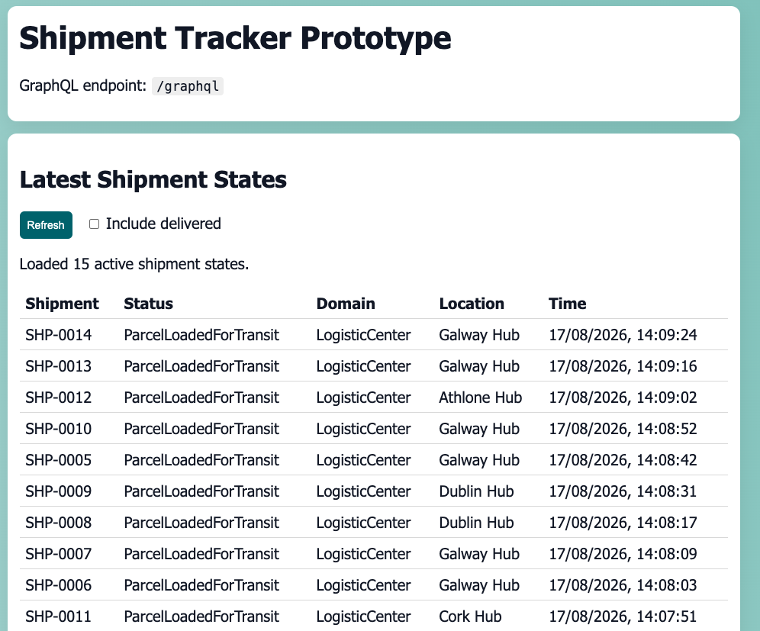
Figure 6 - User interface view of all events

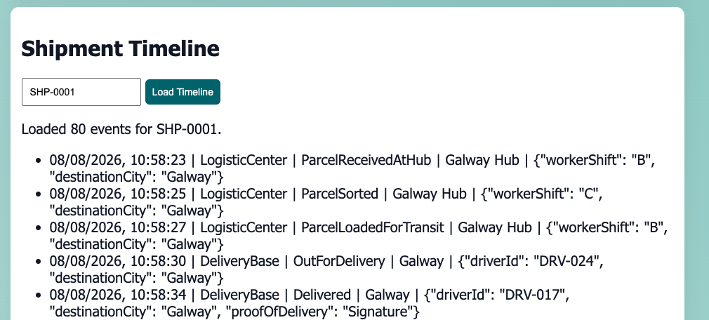
Figure 7 - User interface view of events for SHP-0001

For the purposes of this prototype it was decided to simulate the events within this miniature postal ecosystem rather than utilise actual barcode scanners or handheld devices. The simulation configuration is considered as test infrastructure and is not part of the proposed enterprise architecture. In Figure 8 we can see the flow of shipment event data through the baseline architecture utilising a single AKS cluster.
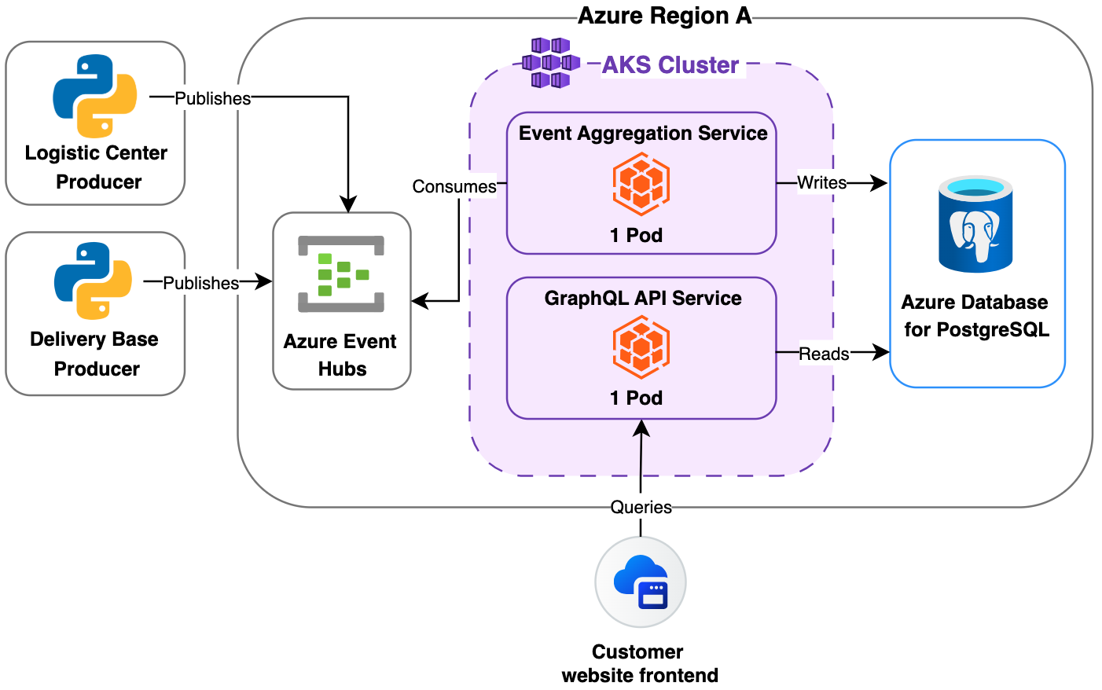
Figure 8 - Baseline architecture
Events from both of the producer domains remain independent until the aggregation step. Every event contains a common shipment ID which allows for the matching of events to specific parcels even if the data comes from individual domains. The Event Aggregation Service, deployed using a single Kubernetes Pod, consumes the events from the Azure Event Hubs and processes them. The resulting data is then written to the PostgreSQL instance. The GraphQL API, also deployed using a single Pod, then queries the stored data and presents it to downstream consuming microservices via its endpoint. The producer domains remain decoupled while the consolidated data still reaches the downstream systems that require it. The overall data flow therefore is:
- Producer Domain Microservices
- Azure Event Hubs
- Event Aggregation Service
- PostgreSQL
- GraphQL API
- Consumer Domain Microservice frontend
    - Aggregation and Materialised Read Model
The Event Aggregation Service combines the shipment events that it consumes from the “Logistic Centre” and “Delivery Base” domains. It creates a consolidated representation of each parcel by utilising an assigned shipment_id to associate events from different domains with each other if the ID is matching. Two PostgreSQL tables are used to store the data from these processes. The all_shipment_events tables is used to store every single event received by the Event Aggregation Service. This can be used to view the entire history associated with any shipment. The other table is called current_shipment_state. It is used as a materialised read model which stores the most recent event associated with a shipment. When a newer event is processed by the Event Aggregation Service, its details replace those of the older event, thus always showing the latest data for the parcel. This means that downstream consumers do not need to track the historic data themselves, and can simply look up that current state of the shipment. They can query the underlying data by calling the endpoint of the GraphQL API. This works for both of the described tables.
In this baseline architecture the Event Aggregation Service and the GraphQL API are each deployed as a single Kubernetes Pod. This means that if the Pod fails there will be no processing of events and the downstream consumers cannot reach their required data. Despite Azure Event Hubs potentially being able to persist the topic data while the other services are offline, no new events will be able to enter the materialised read model in the PostgreSQL database. This will remain the case until the services can be resumed. The result is that that current_shipment_state data rapidly becomes out of date. Even if the GraphQL Pod were still available and could answer query calls, the data that would get transmitted would quickly become obsolete and misleading. This situation highlight why the Event Aggregation Service is a SPoF that requires a high availability architecture to ensure its continued operation throughout an incident.
  - High Availability Design
The previously discussed baseline architecture highlights that a SPoF is created when relying on one instance of the Event Aggregation Service. Therefore, a high availability design is required to mitigate this SPoF. Such a design is show in Figure 9. Here we can see an architecture that provides progressive redundancy focused on the Pod, Availability Zone and regional levels. Every larger level is designed to protect the Event Aggregation Service from bigger and more widespread failures. In this intended goal is that even during a major regional outage there will still be an operational instance of the Event Aggregation Service running. This instance should be able to perform the key functions required of the service without any major issues being felt by the downstream consumers. This design is configured so that it will be possible to evaluate factors such as availability, operational complexity, cost and recovery time during an incident.
Within Figure 9 multiple technologies and communication paths are visible. The starting point on the left side shows the primary Azure Region A. In this Azure region the initial Event Aggregation Service and GraphQL containerised microservices run as Pods in an AKS cluster. If a single Pod fails, another replica Pod within the same deployment can continue the processing operations. If the entire Availability Zone has an issue then another Availability Zone with replica Pods takes over. If the entire region suffers an outage then operations are diverted to Azure Region B with its own AKS cluster and replica Pods. This infrastructure will be tested with both active-passive and active-active configurations to evaluate the differences in recovery time, cost and complexity.
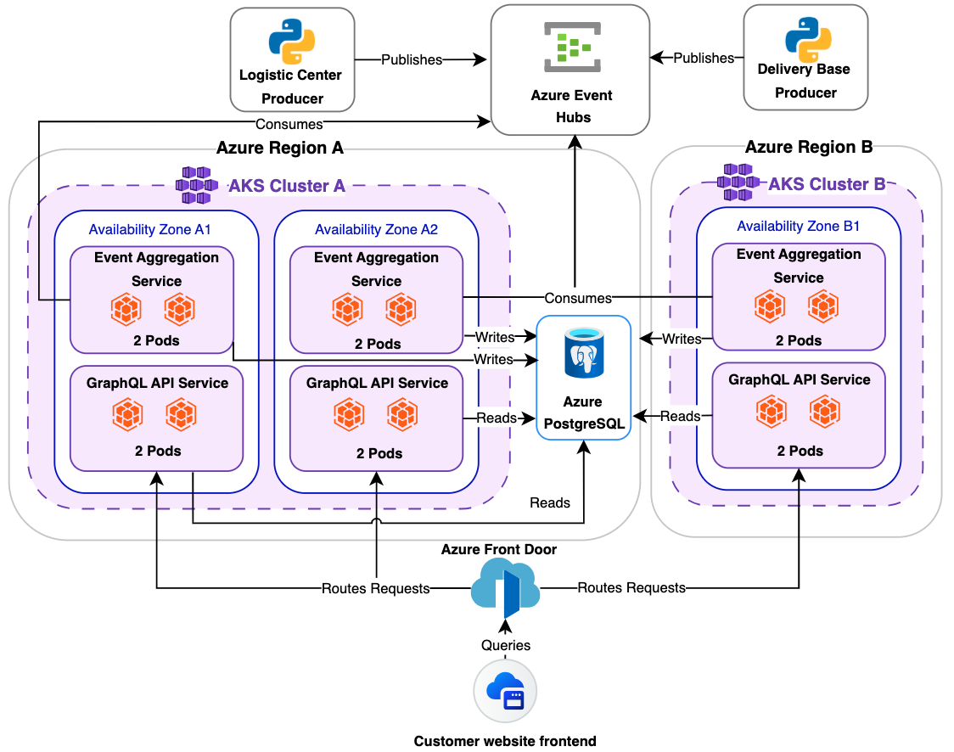
Figure 9 - Final High Availability Architecture
The PostgreSQL instance and Azure Event Hubs are not designed to have high availability in this experiment and are considered as supporting infrastructure only. Similarly, the python based Logistic Centre, Delivery Base and Customer website frontend microservices will not be configured to have high availability. The data flow in this diagram originates from the producing domain services which publish events into Azure Event Hubs. From here the Event Aggregation Services consume the event data from their individual high availability designs locations. The high availability configuration being tested determines the behaviour of the Event Aggregation Service. In the active-passive configuration, Pods within the primary Region A deployment process the events, while the deployment in Region B can be activated in the event of a regional failure. In the active-active configuration, all instances in every Availability Zone and region are part of the same consumer group and are available to process assigned event partitions. Each successfully processed event is written to the PostgreSQL DB. Similarly, in the active-active configuration, the GraphQL API instances can concurrently operate. Azure Front Door is responsible for routing requests to healthy API endpoints, while AKS routes requests between Pods to manage the work load within the cluster. Figure 10 shows the active parts of the design for when the system is operating in normal conditions without any failures occurring.

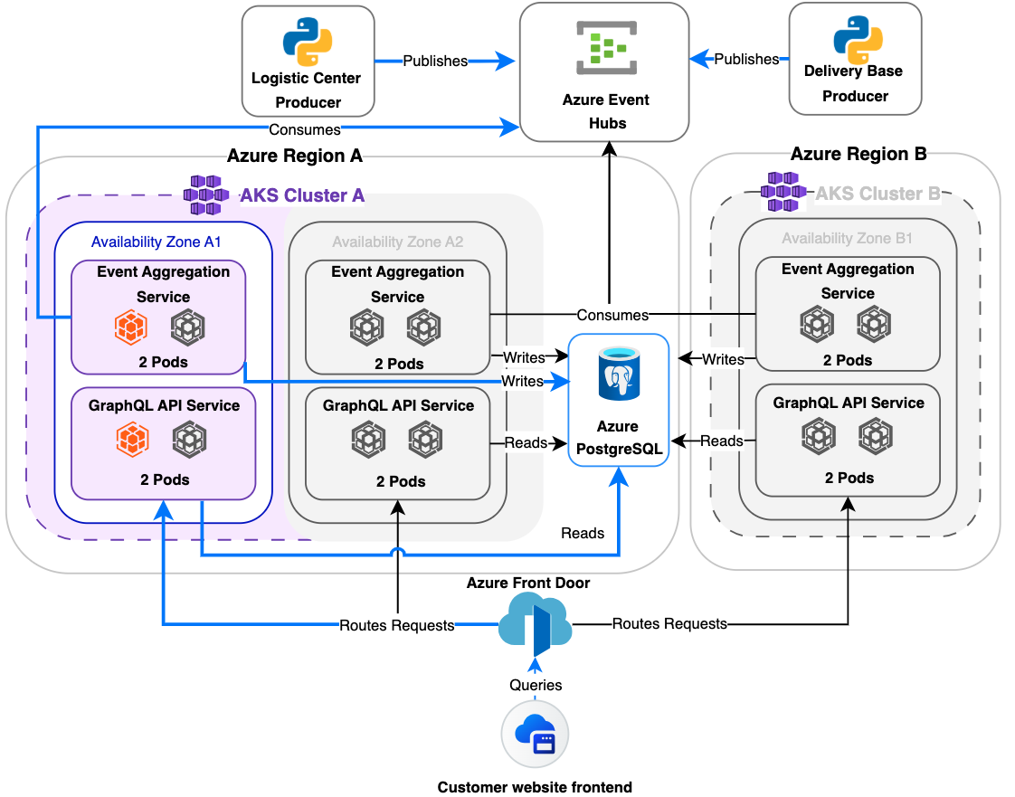
Figure 10 - Normal Operation

    - Pod Replication
The initial level of high availability is achieved by utilising Kubernetes’ Pod replication feature. In the same Availability Zone of a single AKS cluster deployment it is possible to run replica Pods. Instead of having only one Event Aggregation Service Pod the design uses multiple replica Pods. In the event that the primary Pod crashes or is de-activated, its workload is continued by one of the replica Pods. Kubernetes constantly checks the states of all the Pods and restarts or replaces them if the current reality does not match its declarative configuration. Since the Event Aggregation Service replicas all participate in the same Kafka consumer group, partitions can be dynamically assigned to the available instances. This ensure that event processing can continue in an accurate and structured manner.
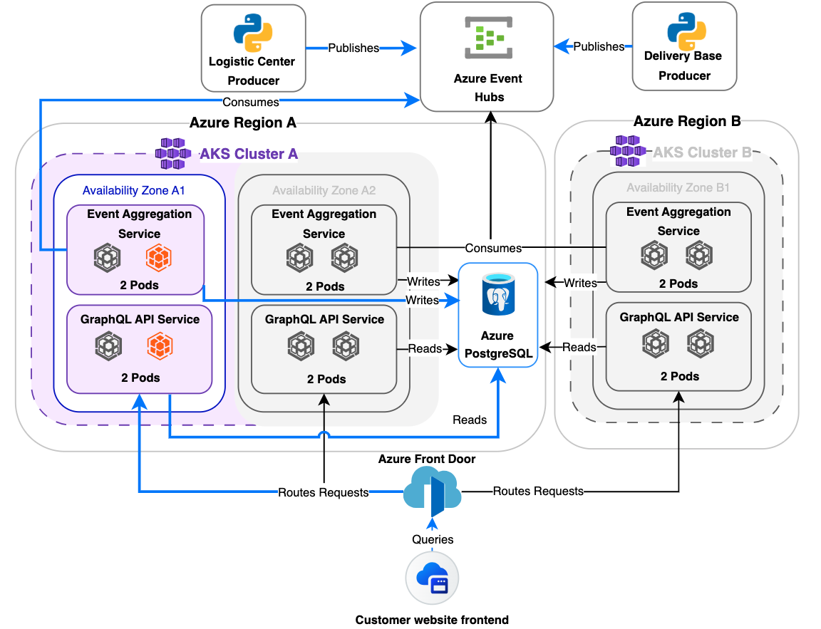
Figure 11 - Pod-Level Failover

For the purpose of this research, it was decided that Two Event Aggregation Service Pods are deployed in each active Availability Zone. This number could be higher, but two adequately demonstrates the failover concept. Having more than one Pod replica ensures that if the failure is just as the Pod level, there is no need to failover to another Availability Zone or Azure Region. The processing will simply be continued by the replica Pod as shown in Figure 11. The GraphQL Pods follow the same behaviour. If one GraphQL Pods fails then another can be used to service the query requests originating from the downstream consumer applications. AKS handles the routing within the cluster, ensuring that requests are sent to healthy GraphQL API Pods, and cleaning up unhealthy ones. The Pod replication feature ensures that there is protection against application instance failure, but it does not prevent issues at the Kubernetes node, Availability Zone or Azure Region levels. The next sections will present solutions to those problems.
    - Availability Zone Resilience
The second level of resilience lies at the Azure Availability Zone. Azure Availability Zones are separate infrastructure components that are responsible for providing Azure services within a single Azure Region. An Azure Region can contain multiple Availability Zones, with each zone representing a physically separate location containing one or more data centres. Each zone is located on a separate site and has independent networking, cooling and power resources (Microsoft, 2026d). This means that when the infrastructure experiences faults at one data centre, resources operating within an unaffected Availability Zone can continue servicing the workload. This decreases the risk of a single data centre failure disrupting the operations of the applications that make use of Availability Zone feature.
For the purposes of this design the AKS Cluster A will span two Availability Zones. The cluster will operate replica Pods across these two zones for both the Event Aggregation Service and the GraphQL API. AKS has the ability to operate node pools across Availability Zones, meaning that replicated Pods running on nodes within unaffected zones can continue processing even if another zone becomes unavailable (Microsoft, 2026b). In Figure 12 we can see how the design for how the Event Aggregation Service and GraphQL API Pods can continue to function even when an entire Availability Zone A1 goes offline in the cluster. Azure Front Door continues to route requests to the healthy regional AKS endpoint, while AKS distributes the requests to healthy GraphQL API Pods within the surviving infrastructure. This configuration provides a higher level of availability than just Pod replication, since an entire data centre can now go offline but the mission-critical services can continue operating despite the loss of one Availability Zone. However, this configuration does not protect the services if the entire Azure Region has an outage.
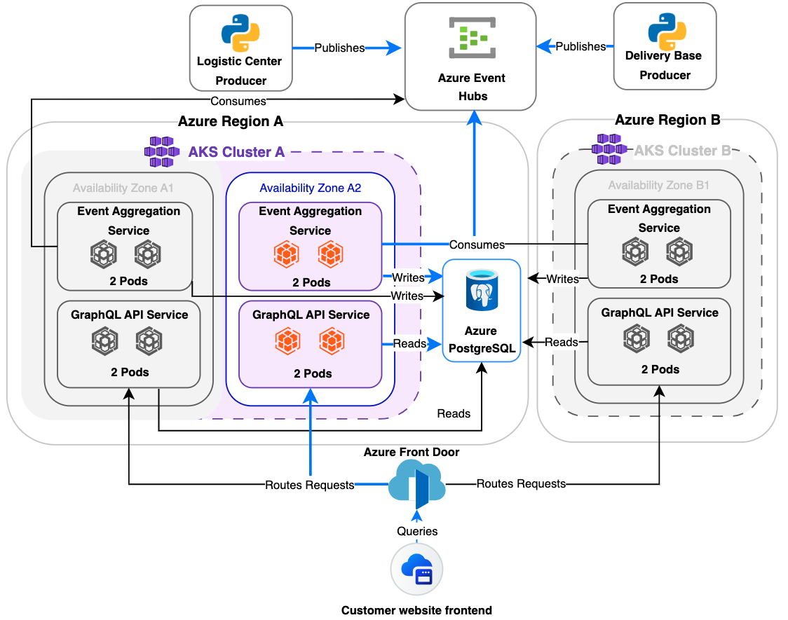
Figure 12 - Availability Zone Failover

    - Multi-Region Resilience
The third level of resilience proposed for this design is at the Azure Region level. Azure Regions consist of one or more data centre which are connected fault tolerant network connections (Microsoft, 2026e). As of 2026, Microsoft provides 70 Azure Regions worldwide, each with their own data residency boundary (Microsoft, 2026e). In the configuration shown in Figure 13 AKS Cluster A is no longer available since the entire Azure Region A has become unavailable while the services in Azure Region B are configured to take over. In this specific scenario the resources can be either passively prepared or actively running. In the passive scenario, the resources need to be activated once a failure occurs in Azure Region A. Once activated, the Event Aggregation Service in Region B can begin processing events and the GraphQL API can service downstream requests. This approach, while slower, is more cost efficient.
The alternative is to run the Active-Active configuration. In such a scenario, the resources are already running replica Pods in Azure Region B and participate in the workload during normal conditions. Event Aggregation Service Pods in both regions participate in the consumer group and are prepared to process assigned event partitions, while Azure Front Door routes to the healthy API endpoints. When a failure happens at Azure Region A requests are only routed to Azure Region B. The Event Aggregation Service and GraphQL Pods located in Azure Region B handle the entire workload. This approach is expected to drastically shorten the recovery time, but requires more financial resources to maintain two active regional deployments.

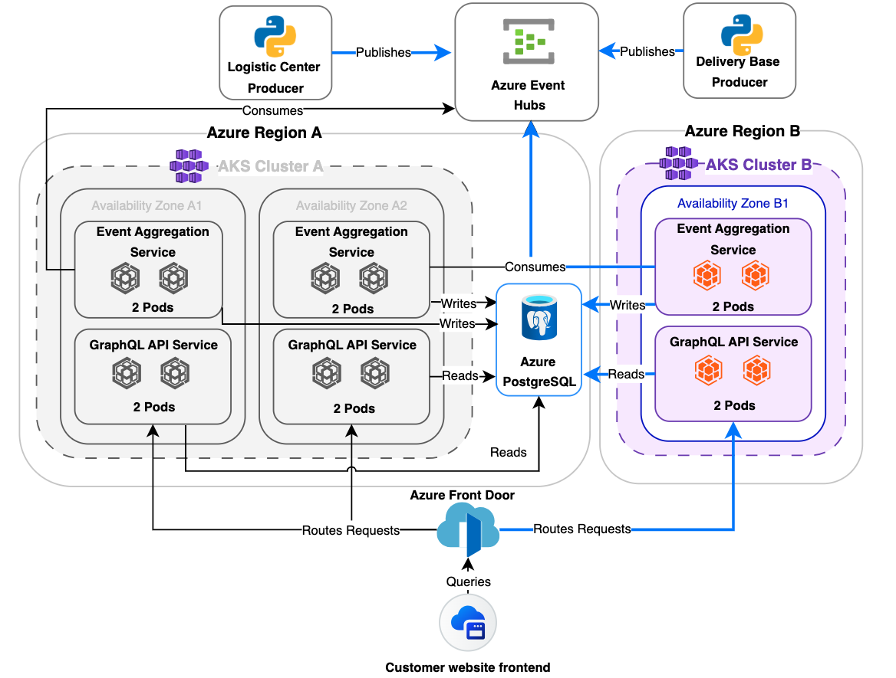
Figure 13 - Regional Failover

    - Event Aggregation Service internal safeguards
When an instance of the Event Aggregation Service has an issue or a failure, specific logic ensures that no data is lost during the database (DB) transaction once a new instance takes over. In Figure 12 we see that there are certain steps that get carried out during the processing of events that are consumed from the Azure Event Hubs using its Kafka-compatible interface and then written to the Azure PostgreSQL. In step 1, the process to write to the DB initiates. In step 2 the latest event consumed from Kafka is prepared to be inserted into the table all_shipment_events of the DB. Step 3 deals with the preparing the data for the table current_shipment_state.

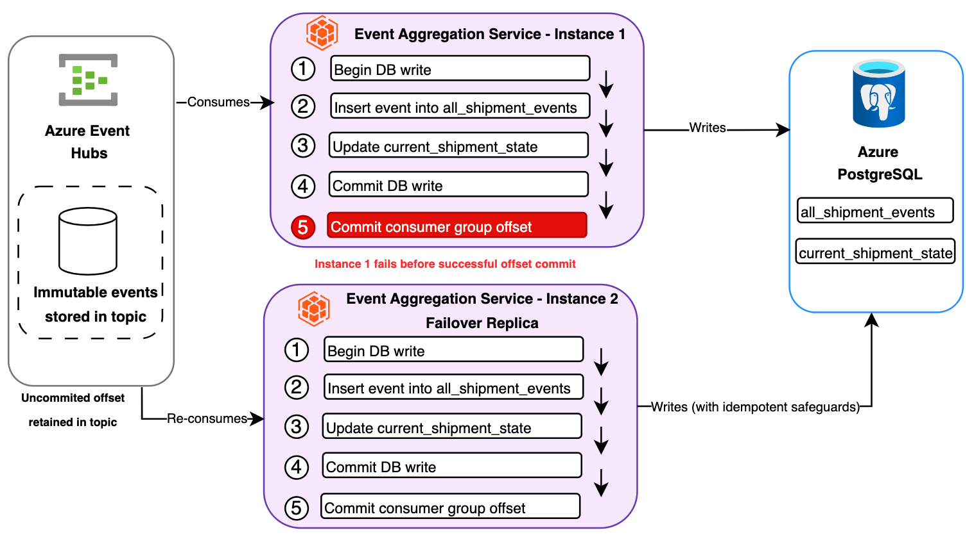
Figure 14 - Event Aggregation Service failover logic

Once all the data is ready, SQL commands are used to write the data to the DB in step 4. During this write there are safeguards to prevent duplicate historical events from being stored in all_shipment_events. Each event contains an event_id, which is used as a primary key. If a conflict is detected with a duplicate event_id, then the SQL “ON CONFLICT DO NOTHING” logic ensures that the attempted insert is ignored. This prevents duplicate data from being stored in the DB and provides idempotency.
Every event associated with a shipment contains an incrementing event_version. Before the event is written to the current_shipment_state table a check is performed upon the event_version value to compare it with the version already stored for the shipment. If the incoming event_version is newer than the version currently stored for the shipment, the materialised state is update

ed. Thus, older events cannot overwrite the most recent and newer event, preventing older events from falsely showing as the current state. This mechanism protects the materialised read-model from out-of-order event processing.
A single PostgreSQL transaction is used to update both of the tables. The consumer group offset is only committed once the transaction has successfully completed. If instance 1 of the Event Aggregation Service manages to complete the write into the DB in step 4 but fails before committing the consumer group offset in step 5, then the event will be re-consumed by instance 2. Therefore, the event-version and idempotency safeguards ensure that instance 2 can attempt to write to the DB again without creating incorrect data entries. Without these mechanisms it is possible that the PostgreSQL would have data that would be misleading and lead to incorrect shipment information being propagated to downstream logistics and customer-facing applications. Thus, such safeguards are crucial in maintaining the accurate operations of the Event Aggregation Service in the event of a failover to surviving instances.

  - Evaluation Metrics
An evaluation of the proposed architectures will be performed by introducing failures intentionally into the systems. These failures will be artificially triggered at the Pod, Availability Zone and Azure Region levels. The goal is to measure how the systems respond throughout the failure event and determine how effective the designs are in providing high availability. The metrics that will measured are:
- Availability: The availability of the various mission critical components and their continued functionality. Key focus on the Event Aggregation Service and GraphQL API.
- Recovery time: How quickly do services recover after an incident has started?
- Cost: What are the financial costs of the architectures?
- Continuity of event processing: Are events reliably processed during and after a failure?
- Data integrity: Is the quality and correctness of data in line with the requirements of a regulated postal enterprise? Are duplicated historical events prevented from reaching the PostgreSQL DB? Does the materialised read model maintain the latest shipment state?
- Complexity: How complex is each architecture to deploy and maintain?
These metrics will be used compare the various proposed architectures and determine the extent to which each high-availability strategy improves availability over the baseline architecture.
  - Design Conclusion
The proposed highly available architectures for the Event Aggregation Service and its accompanying components were presented in this chapter. The metrics that will be used to evaluate the high availability strategies were established. The baseline architecture that will be used as a reference point was discussed which reinforced the need for a highly available alternative. This baseline was used as the foundation upon which the proposed highly available architecture extends upon.
These extensions provide progressively more redundancy and resilience. Starting with Pod replication, then Availability Zone distribution and finally various implementations of regional resilience. Safeguards are included in the proposed design, ensuring that the Event Aggregation Service application will implement idempotent writes, event versioning and transactional processing. The aim is to maintain data integrity even during a failure scenario. The following chapter will present the implementation of the highly available architectures described in the Design chapter.

- Implementation
  - Implementation Overview
The implementation of the prototype was carried out using Visual Studio Code as a text editor, Docker Desktop as a local environment for running containerised applications, and a Student Azure account for deploying resources to the Azure cloud. The deployable prototype was initially planned to encompass all of the features described in the design chapter. However, a limitation was discovered during the implementation phase relating to the student Azure account. The Azure student account which the author has access to did not support the use of Azure Front Door. Due to this limitation the regional high availability designs could not be experimentally completed. This limitation will be discussed in later parts of the thesis that examine possible future work that could be carried out to further explore this research area.
The prototype that was implemented focused on application-level data processing integrity, Pod resilience in a local Kubernetes cluster, an Azure baseline deployment, and Availability Zone failover within AKS. The various required Python microservices, Kafka compatible event broker, and PostgreSQL DB were initially deployed as containers using Docker Compose. The Event Aggregation Service and GraphQL API were then deployed to the local Kubernetes environment, while the Kafka-compatible broker and PostgreSQL remained as supporting Docker services. They were tested to ensure the core functionalities worked as desired. Later, the same set up was then modified and deployed to Azure in the Italy North region. Azure Event Hubs was configured to act as the event broker. Azure Container Registry was used to store the images of the containerised microservice applications. AKS was configured to run the Event Aggregation Service and GraphQL API. Azure PostgreSQL was used as the persistent cloud based DB. The manner in which the events were being processed remained the same, but the infrastructure that hosted the operations could be progressively changed to provide greater redundancy. The Producer microservices were not deployed to the cloud and controlled events were instead published externally from the experiment host to Event Hubs.

  - Event-Producing and Aggregation Microservices
The event producing microservices were implemented to symbolically represent part of a parcel ecosystem that produces shipment events. One producer represented the “Logistic Centre” domain and the other the “Delivery Base” domain. The Logistic Centre producer published events such as “ParcelReceivedAtHub”, “ParcelSorted”, and “ParcelLoadedForTransit”. The Delivery base producer published events such as “OutForDelivery”, “DeliveryAttempted”, and “Delivered”. The producers were separated in order to reflect the distributed nature of modern postal organisations as discussed in the domain driven enterprise chapter of this thesis. This design highlighted that events can be generated from independent sources with individual contexts.
Both event producers followed a shared event structure, with each event containing an event ID, a shipment ID, an event version, a domain identifier, an event type, a timestamp field, and a location field. Different events relating to the same shipment could be matched during event processing using the shipment ID field. The shipment ID was also used as the Kafka message key. Throughout the local deployment phase, the events were published by the producers to Redpanda using its Kafka compatible interface. During the Azure deployment phase events were published externally to Azure Event Hubs via its Kafka compatible endpoint.
Python was used to code the Event Aggregation Service Microservice which consumed the event streams published into by both of the event producers from the upstream domains. The Event Aggregation Service’s purpose is to process shipment event data and prepare it to be stored in the PostgreSQL DB. Each time an event is consumed by the Event Aggregation Service it stores it in the all_shipment_events table in the PostgreSQL DB. This acts as a log that could then be used by the GraphQL API to fetch all events that are related to a specific shipment. A separate table called current_shipment_state was used to store the latest event relating to a shipment. This allows the GraphQL API to fetch the latest state of a specific shipment. The GraphQL API was also implemented using Python. Health and readiness endpoints were implemented for both the GraphQL API and the Event Aggregation Service so that the Docker, Kubernetes and Azure could check the microservices and understand if they were operational or not. The Event Aggregation Service and GraphQL API components discussed in this subchapter remained stable throughout the various deployments, while the supporting infrastructure varied depending on the specific deployment being evaluated.
To display the shipment data and act as a downstream consumer of the GraphQL API, a basic web-based user interface was implemented. It features a search function that allows a user to query all events related to a shipment, as seen in Figure 7. It also provides an overview of the current state of all shipments that have not been delivered yet, as seen in Figure 6. A button allows for delivered shipments to also be included in the overview.
  - Event Processing and Data-Integrity Implementation
The prototype was implemented to avoid shipments being processed incorrectly. Specifically the Event Aggregation Service was configured to ensure that the current shipment state table would only be updated with the most recent event for a shipment. It uses the event_version to determine whether an incoming event is newer than the currently stored state, and if an event arrived out of order, delayed or was processed more than once it would not overwrite a newer state. This was combined with PostgreSQL transaction handling and using manual Kafka offset management, to ensure that event processing remained consistent and duplicate deliveries could be handled idempotently.
When the Event Aggregation Service consumes an event from the event broker, it opens a PostgreSQL transaction. This transaction is used to write the new event into the all_shipment_events table and if appropriate it also updates the current_shipment_state table. Since both DB updates are part of the same transaction, one database operation cannot be committed without the other if processing fails during the transaction. The unique event_id of each event is used by the PostgreSQL DB to stop duplicate events being written into the all_shipment_events table. The DB insert uses the “ON CONFLICT DO NOTHING” logic, as seen in Figure 15, to ensure the duplicates are not written into the table.
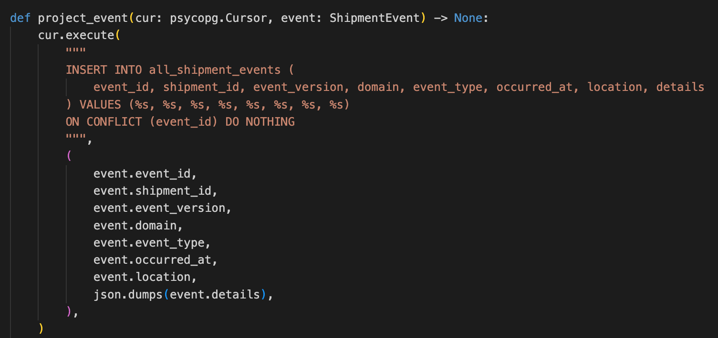
Figure 15 - ON CONFLICT DO NOTHING logic for all_shipment_events table
The event_version is used to ensure that only the latest version is used to update the current_shipment_state table, as seen in Figure 16. This event_version is generated by the producer side logic. In the case of this prototype the event_version is assigned in a sequentially controlled and simulated manner to avoid conflicts. In a postal enterprise there would need to be extra logic and components to ensure this version assignment proceeds with concurrency controls to avoid the same version being assigned by the independent domains.
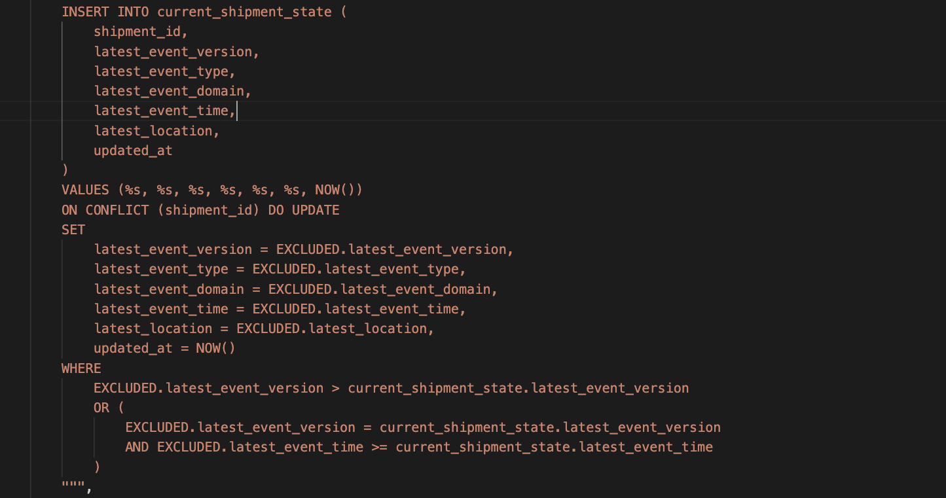
Figure 16 - ON CONFLICT DO NOTHING logic for current_shipment_state table
Kafka offset commits do not complete automatically once the Event Aggregation Service read an event from a partition. Only after the PostgreSQL transaction has successfully been completed does the offset commit occur. This is important, since it ensures that events are correctly re-processed in case any part of the procedure gets interrupted. When, for example an instance of the Event Aggregation Service unexpectedly goes offline half way through processing an event, a new or different instance can take over from the last committed offset and ensure that the necessary data reaches the PostgreSQL DB tables. The same is true if the PostgreSQL transaction experiences a failure. The Event Aggregation Service would simply process the same event again and re-attempt to send the data to the DB. If the PostgreSQL is successful but the Event Aggregation Service fails before committing the offset, the event would get processed again but the DB would not create a duplicate historical record due to the event_id safeguard, while event_version prevents an older event from overwriting a newer current state. Therefore, this configuration ensures that events that are uncommitted are re-delivered until processing is fully completed and the offset is successfully committed.
  - Azure Kubernetes Service and Azure High Availability Deployment
The prototype was deployed to Azure and used the same Event Aggregation Service and GraphQL API containers used in the local setup. The images of the container were pushed to Azure Container Registry, see Figure 15, and Azure Event Hubs, see Figure 15, was used as the Kafka compatible event broker. All persistent storage requirements for the shipment tables were facilitated with Azure Database for PostgreSQL, see Figure 17. AKS was used to run and orchestrate the operations of the containerised applications.
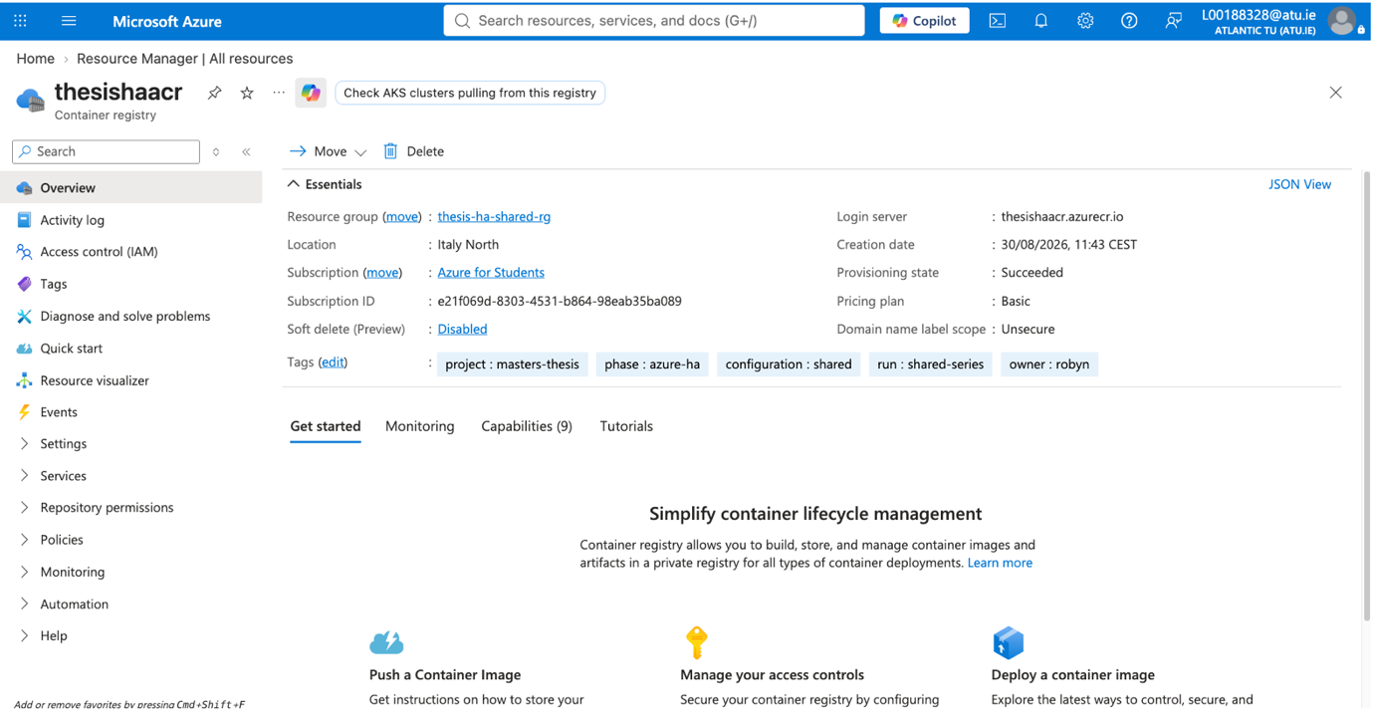
Figure 17 - Azure Container Registry depoyed in Azure
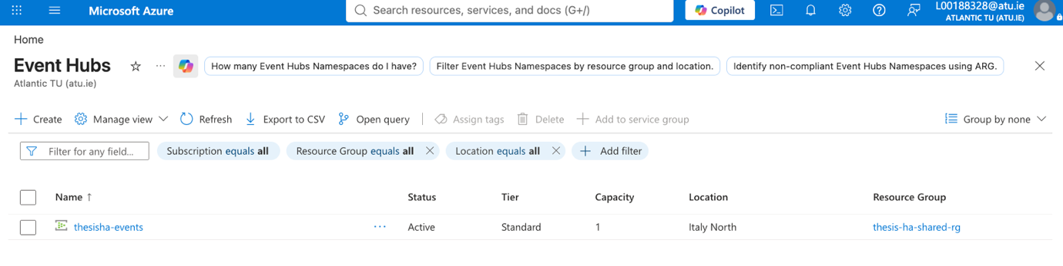
Figure 18 - Event Hubs deployed in Azure

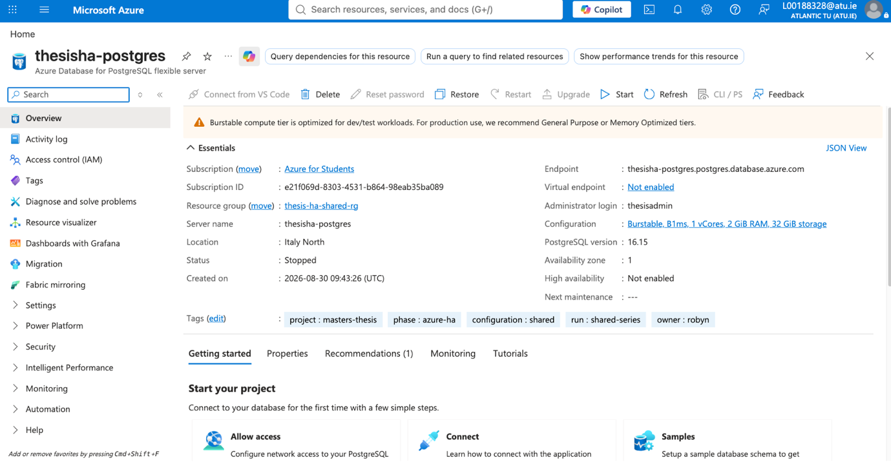
Figure 19 - PostgreSQL DB provisioned in Azure
The first deployment was labelled as E1 and was used to confirm that the baseline Azure architecture was functioning. The Azure region chosen was Italy North, due to it being available on the Azure student account license. One AKS cluster was deployed with a separate system node pool for hosting Kubernetes system workloads and a non-zonal application node pool for running the workloads. A single instance of both the Event Aggregation Service and GraphQL API were deployed. There was no configuration of Availability-Zones in this baseline deployment.
The next deployment was labelled as F1, and was an extension of E1, but also contained Availability-Zone level redundancy. As seen in Figure 15 and Figure 16, two zonal application node pools were configured in AKS, with appzone1 being configured for Zone 1 and appzone2 being configured for Zone 2. These two pools were used to replicate instances of the Event Aggregation Service and the GraphQL API pods. These 2 application were not allowed to run on the System node pool. Simulated failures were created where one of the application node pools was stopped using the AKS control plane.

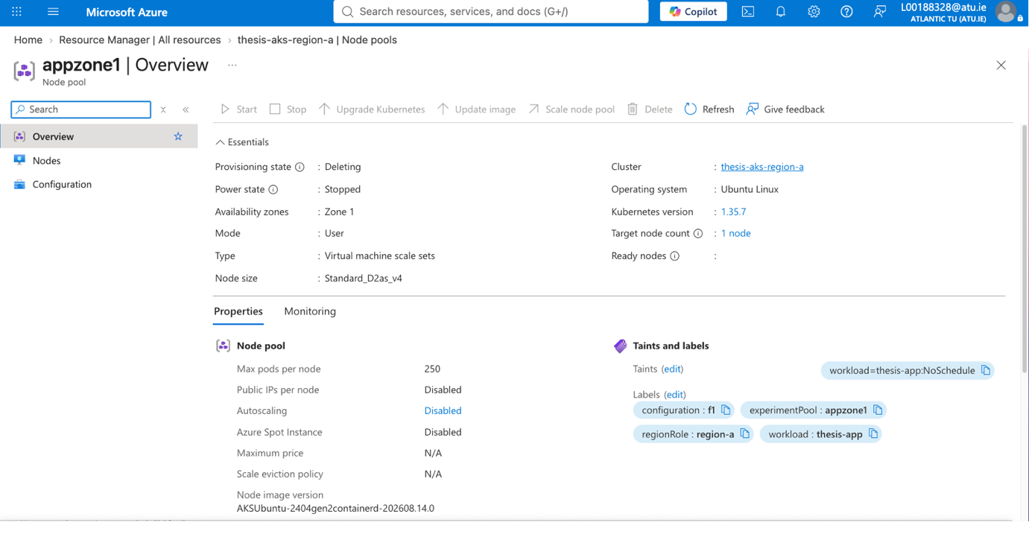
Figure 20 - AppZone1
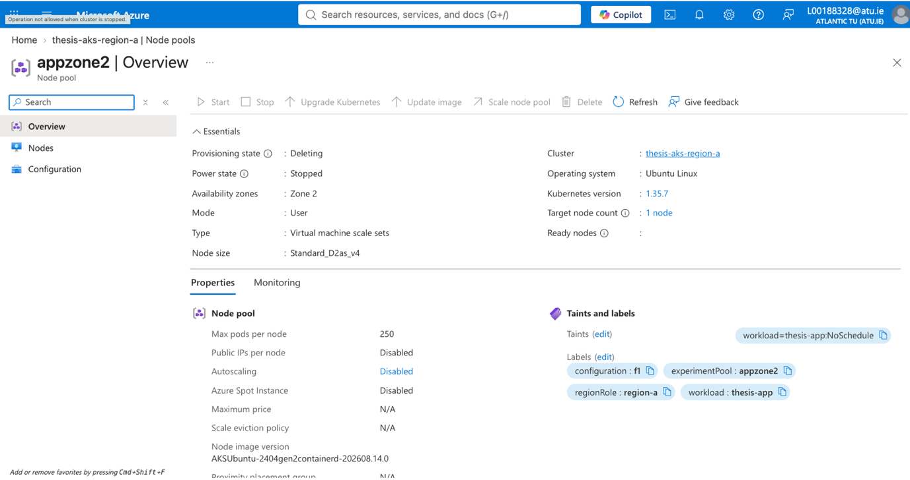
Figure 21 - AppZone2
Due to the planned Azure multi-region experiments, another AKS cluster was provisioned in Norway East. However, when attempting to configure Azure Front Door it was discovered that the Azure student license was not authorised to use that resource, as documented in Figure 15. The lack of this critical routing component meant that the planned regional active-passive and active-active experiments could not be conducted.
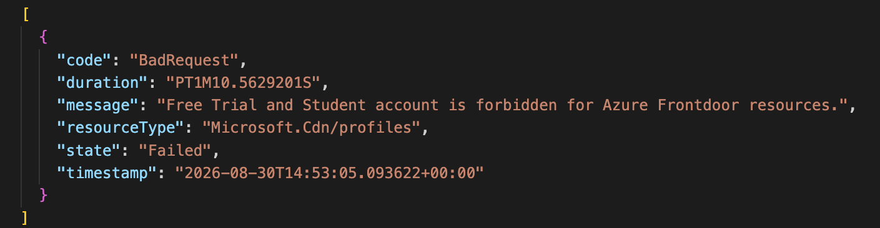
Figure 22 - Sanitised Azure Front Door deployment error
All the deployed resources are visible in Figure 19 and Figure 20.
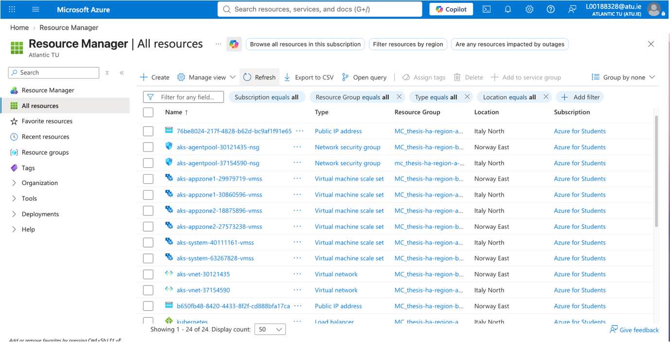
Figure 23 - Azure resources 1

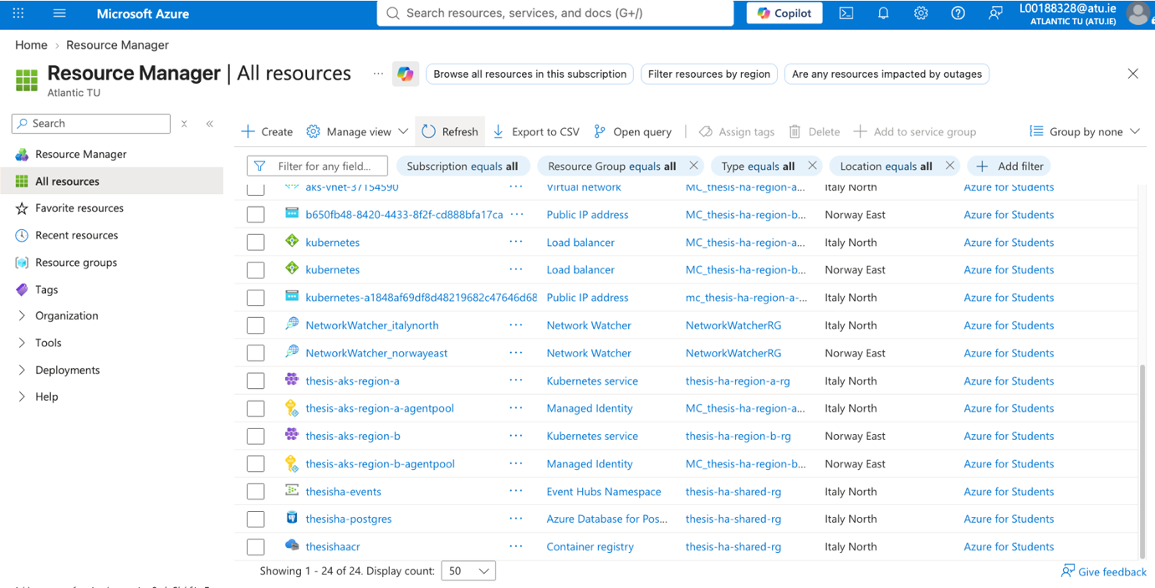
Figure 24 - Azure resources 2

  - Experimental Instrumentation and Monitoring
  - Implementation Conclusion

- Test Strategy and Results and Analysis
- Analysis
- Conclusions

Reduce the downtime, how do we measure that. Do we do load testing?
Explain how Kubernetes deals with watching the pods, watchdog, maybe a cron job to check the watch?
The chain of services need to be intact.
What does HA mean?, standard, pick specifics that will be written up in the implementation. You need to ensure there is a backup of this end.

infrastructure/event-stream resilience exists, but the aggregation layer can remain an application-level critical dependency requiring redundancy and failover.

References

Alanda, A. et al. (2025) “Scaling Kubernetes Architectures for High Availability in Cloud,” 2025 International Conference on Computer Sciences, Engineering, and Technology Innovation (ICoCSETI). 2025 International Conference on Computer Sciences, Engineering, and Technology Innovation (ICoCSETI), Jakarta, Indonesia: IEEE, pp. 818–823. Available at: https://doi.org/10.1109/ICoCSETI63724.2025.11020084.
Alyahya, A., Tipper, D. and Babay, A. (2025) “Availability and Cost Analysis of Network-Attack-Resilient Byzantine Fault Tolerant Systems,” IEEE Transactions on Network and Service Management, 22(5), pp. 3895–3908. Available at: https://doi.org/10.1109/TNSM.2025.3589936.
Angela Dawn Lawson (2020) Deploying the right technology- a framework for digital strategy and selection at the United States Postal Service to shape the future of work. Thesis. MIT.
Armbrust, M. et al. (2009) Above the Clouds: A Berkeley View of Cloud Computing. University of California at Berkeley.
Aung, T. and Maw, A.H. (2017) “Analytics of Reliability for Real-Time Big Data Pipeline Architecture.” 1st International Conference on Advanced Information Technologies, Yangon, Myanmar. Available at: https://meral.edu.mm/records/6257 (Accessed: May 28, 2026).
Callou, G. and Vieira, M. (2024) “Availability and Performance Analysis of Cloud Services,” Proceedings of the 13th Latin-American Symposium on Dependable and Secure Computing. LADC 2024: 13th Latin-American Symposium on Dependable and Secure Computing, Recife Brazil: ACM, pp. 262–271. Available at: https://doi.org/10.1145/3697090.3697105.
Choudhary, S.K. (2025) “IMPLEMENTING EVENT-DRIVEN ARCHITECTURE FOR REAL-TIME DATA INTEGRATION IN CLOUD ENVIRONMENTS,” INTERNATIONAL JOURNAL OF COMPUTER ENGINEERING AND TECHNOLOGY, 16(1), pp. 1535–1552. Available at: https://doi.org/10.34218/IJCET_16_01_113.
Costa, A.B. and Brito, M.A. (2022) “Enterprise Architecture Management : Constant maintenance and updating of the Enterprise Architecture,” 2022 17th Iberian Conference on Information Systems and Technologies (CISTI). 2022 17th Iberian Conference on Information Systems and Technologies (CISTI), Madrid, Spain: IEEE, pp. 1–5. Available at: https://doi.org/10.23919/CISTI54924.2022.9820068.
Deng, L. (2026) “LMID: A Comprehensive Multimodal Dataset for Failure Prediction in Cloud Computing Systems.”
Erdogmus, H. (2009) “Cloud Computing: Does Nirvana Hide behind the Nebula?,” IEEE Software, 26(2), pp. 4–6. Available at: https://doi.org/10.1109/MS.2009.31.
Evans, E. (2004) Domain-driven design: tackling complexity in the heart of software. Boston: Addison-Wesley.
Ezzeddine, M. et al. (2021) “On The Design of SLA-Aware and Cost-Efficient Event Driven Microservices,” Proceedings of the Seventh International Workshop on Container Technologies and Container Clouds. Middleware ’21: 22nd International Middleware Conference, Virtual Event Canada: ACM, pp. 25–30. Available at: https://doi.org/10.1145/3493649.3493657.
Florian Springer and Christoph Emmersberger (2008) Event Driven Business Process Management taking the Example of Deutsche Post AG: An evaluation of the Approach of Oracle and the SOPERA Open Source SOA Framework. Diploma Thesis. University of Applied Sciences Regensburg.
Ghosh, A. (2025) “Transforming Enterprise Systems through Event-Driven Architecture: Implementation, Benefits, and Future Trends,” International Journal of Scientific Research in Computer Science, Engineering and Information Technology, 11(1), pp. 3507–3514. Available at: https://doi.org/10.32628/CSEIT251112347.
Gulisano, V. and Margara, A. (2024) “Aggregates are all you need (to bridge stream processing and Complex Event Recognition),” Proceedings of the 18th ACM International Conference on Distributed and Event-based Systems. DEBS ’24: The 18th ACM International Conference on Distributed and Event-based Systems, Villeurbanne France: ACM, pp. 66–77. Available at: https://doi.org/10.1145/3629104.3666032.
Hassel, A. and Sieker, F. (2022) “The platform effect: How Amazon changed work in logistics in Germany, the United States and the United Kingdom,” European Journal of Industrial Relations, 28(3), pp. 363–382. Available at: https://doi.org/10.1177/09596801221082456.
Hippchen, B. et al. (2017) “Designing Microservice-Based Applications by Using a Domain-Driven Design Approach.”
Hongyu, Y. and Anming, W. (2023) “Migrating from Monolithic Applications to Cloud Native Applications,” 2023 8th International Conference on Computer and Communication Systems (ICCCS). 2023 8th International Conference on Computer and Communication Systems (ICCCS), Guangzhou, China: IEEE, pp. 775–779. Available at: https://doi.org/10.1109/ICCCS57501.2023.10150977.
Ijsrset and Dr. Susheel Kumar Tiwari (2024) “International Journal of Scientific Research in Science, Engineering and Technology,” International Journal of Scientific Research in Science Engineering and Technology, 1(1), p. 1. Available at: https://doi.org/10.32628/IJSRSET.
Ilieva, D., Kolev, D. and Gladchenko, V. (2024) “Investigation of the Impact of Artificial Intelligence and Automation in the Postal Services Sector Labour Market,” 2024 5th International Conference on Communications, Information, Electronic and Energy Systems (CIEES). 2024 5th International Conference on Communications, Information, Electronic and Energy Systems (CIEES), Veliko Tarnovo, Bulgaria: IEEE, pp. 1–7. Available at: https://doi.org/10.1109/CIEES62939.2024.10811359.
International Organisation for Standardisation (2016) “ISO/IEC 25023 Systems and software engineering — Systems and software Quality Requirements and Evaluation (SQuaRE) — Measurement of system and software product quality.” Geneva: ISO.
International Organisation for Standardisation (2023) “ISO/IEC 25010 Systems and software engineering — Systems and software Quality Requirements and Evaluation (SQuaRE) — Product quality model.” ISO.
Ivanov, N. and Tasheva, A. (2021) “A Hot Decomposition Procedure: Operational Monolith System to Microservices,” 2021 International Conference Automatics and Informatics (ICAI). 2021 International Conference Automatics and Informatics (ICAI), Varna, Bulgaria: IEEE, pp. 182–187. Available at: https://doi.org/10.1109/ICAI52893.2021.9639494.
Jade Wright (2025) “Royal Mail confirms Post Office system outage amid issues,” Times & Star, 17 July. Available at: https://www.timesandstar.co.uk/news/national/uk-today/25321694.royal-mail-confirms-post-office-system-outage-amid-issues/.
Jovanović, B., Šarac, D. and Čačić, N. (2025) “Delphi and fuzzy TOPSIS approach for redefining the scope of postal universal service obligation,” Journal of Regulatory Economics, 68(1), pp. 38–52. Available at: https://doi.org/10.1007/s11149-025-09489-6.
Kalske, M., Mäkitalo, N. and Mikkonen, T. (2018) “Challenges When Moving from Monolith to Microservice Architecture,” in I. Garrigós and M. Wimmer (eds.) Current Trends in Web Engineering. Cham: Springer International Publishing (Lecture Notes in Computer Science), pp. 32–47. Available at: https://doi.org/10.1007/978-3-319-74433-9_3.
Karthik Reddy Thondalapally (2025) “Event-Driven Architectures: The Foundation of Modern Distributed Systems,” International Journal on Science and Technology, 16(1), p. 2907. Available at: https://doi.org/10.71097/IJSAT.v16.i1.2907.
Kasaram, C.R. (2023) “Harnessing Asynchronous Patterns with Event Driven Kafka and Microservices Architectures,” Journal of Artificial Intelligence & Cloud Computing, 2(4), p. 1. Available at: https://doi.org/10.47363/JAICC/2023(2)502.
Khajeh-Hosseini, A., Greenwood, D. and Sommerville, I. (2010) “Cloud Migration: A Case Study of Migrating an Enterprise IT System to IaaS,” 2010 IEEE 3rd International Conference on Cloud Computing. 2010 IEEE International Conference on Cloud Computing (CLOUD), Miami, FL, USA: IEEE, pp. 450–457. Available at: https://doi.org/10.1109/CLOUD.2010.37.
Kiani, A.A. et al. (2024) “Catalysing Monolithic to Microsevices Migration: A Strategic Approach Using Refactoring and Pilot Projects,” 2024 International Conference on Engineering &amp; Computing Technologies (ICECT). 2024 International Conference on Engineering &amp; Computing Technologies (ICECT), Islamabad, Pakistan: IEEE, pp. 1–7. Available at: https://doi.org/10.1109/ICECT61618.2024.10581399.
Laigner, R. et al. (2024) “An Empirical Study on Challenges of Event Management in Microservice Architectures.” arXiv. Available at: https://doi.org/10.48550/arXiv.2408.00440.
Liu, G. et al. (2020) “Microservices: architecture, container, and challenges,” 2020 IEEE 20th International Conference on Software Quality, Reliability and Security Companion (QRS-C). 2020 IEEE 20th International Conference on Software Quality, Reliability and Security Companion (QRS-C), Macau, China: IEEE, pp. 629–635. Available at: https://doi.org/10.1109/QRS-C51114.2020.00107.
Macías, A. et al. (2023) “Architecting Digital Twins Using a Domain-Driven Design-Based Approach*,” 2023 IEEE 20th International Conference on Software Architecture (ICSA). 2023 IEEE 20th International Conference on Software Architecture (ICSA), L’Aquila, Italy: IEEE, pp. 153–163. Available at: https://doi.org/10.1109/ICSA56044.2023.00022.
Mahapatra, C. et al. (2026) “Emerging Challenges in Cloud Computing: Addressing Security and Management Concerns,” 2026 International Conference on Intelligent Computing, Networks, and Security (IC-ICNS). 2026 International Conference on Intelligent Computing, Networks, and Security (IC-ICNS), Bhubaneswar, India: IEEE, pp. 1–5. Available at: https://doi.org/10.1109/IC-ICNS68863.2026.11537438.
Maia, D., Correia, F. and Queiroz, P. (2024) “Configurational Patterns of Container Orchestration,” Proceedings of the 29th European Conference on Pattern Languages of Programs, People, and Practices. EuroPLoP 2024: 29th European Conference on Pattern Languages of Programs, People, and Practices, Irsee Germany: ACM, pp. 1–11. Available at: https://doi.org/10.1145/3698322.3698342.
McIlroy, M.D., Pinson, E.N. and Tague, B.A. (1978) “UNIX Time-Sharing System: Foreword,” Bell System Technical Journal, 57(6), pp. 1899–1904. Available at: https://doi.org/10.1002/j.1538-7305.1978.tb02135.x.
Microsoft (2026a) “Cluster management pricing tiers for Azure Kubernetes Service (AKS).” Available at: https://learn.microsoft.com/en-us/azure/aks/free-standard-pricing-tiers.
Microsoft (2026b) “Configure availability zones in Azure Kubernetes Service (AKS).” Available at: https://learn.microsoft.com/en-us/azure/aks/reliability-availability-zones-configure?pivots=azure-cli.
Microsoft (2026c) “Strangler Fig pattern.” Available at: https://learn.microsoft.com/en-us/azure/architecture/patterns/strangler-fig.
Microsoft (2026d) “What are availability zones?” Available at: https://learn.microsoft.com/en-us/azure/reliability/availability-zones-overview?tabs=azure-cli.
Microsoft (2026e) “What are Azure regions?” Available at: https://learn.microsoft.com/en-us/azure/reliability/regions-overview.
Mishra, R. et al. (2022) “Transition from Monolithic to Microservices Architecture: Need and proposed pipeline,” 2022 International Conference on Futuristic Technologies (INCOFT). 2022 International Conference on Futuristic Technologies (INCOFT), Belgaum, India: IEEE, pp. 1–6. Available at: https://doi.org/10.1109/INCOFT55651.2022.10094556.
Miyachi, C. (2021) “The Rise of Kubernetes,” 2021 Cloud Continuum. 2021 Cloud Continuum, Los Alamitos, CA, USA: IEEE, pp. 1–5. Available at: https://doi.org/10.1109/CloudContinuum54760.2021.00002.
Myllynen, T. et al. (2023) “Developing a Conceptual Model for Cross-Domain Microservices Using Event-Driven and Domain-Driven Design,” International Journal of Multidisciplinary Research and Growth Evaluation, 4(1), pp. 635–638. Available at: https://doi.org/10.54660/.IJMRGE.2023.4.1.635-638.
Nerella, H., Sai Puvvada, P. and Borra, P. (2025) “Framework for Kubernetes High Availability and Resilience in Public Cloud,” International Journal of Science and Research (IJSR), 14(3), pp. 1705–1709. Available at: https://doi.org/10.21275/SR250313194616.
Otsetova, A. (2019) “Postal Sector Transformation in Digital Economy,” International Journal, 8(2).
Oumoussa, I. and Saidi, R. (2024) “Evolution of Microservices Identification in Monolith Decomposition: A Systematic Review,” IEEE Access, 12, pp. 23389–23405. Available at: https://doi.org/10.1109/ACCESS.2024.3365079.
Pallempati, I., Lakshmi, D.V. and Das, M.S. (2024) “Handwritten Character Recognition and Vehicle Number Recognition using OCR Method,” 2024 Third International Conference on Trends in Electrical, Electronics, and Computer Engineering (TEECCON). 2024 Third International Conference on Trends in Electrical, Electronics, and Computer Engineering (TEECCON), Bangalore, India: IEEE, pp. 41–45. Available at: https://doi.org/10.1109/TEECCON64024.2024.10939189.
Pan, H. et al. (2024) “Octopus: Experiences with a Hybrid Event-Driven Architecture for Distributed Scientific Computing,” SC24-W: Workshops of the International Conference for High Performance Computing, Networking, Storage and Analysis. SC24-W: Workshops of the International Conference for High Performance Computing, Networking, Storage and Analysis, Atlanta, GA, USA: IEEE, pp. 496–507. Available at: https://doi.org/10.1109/SCW63240.2024.00071.
Platunina, G.P. et al. (2025) “Technological controlling: digital transformation of management decisions,” 2025 International Conference on Engineering Management of Communication and Technology (EMCTECH). 2025 International Conference on Engineering Management of Communication and Technology (EMCTECH), Vienna, Austria: IEEE, pp. 1–5. Available at: https://doi.org/10.1109/EMCTECH65814.2025.11220558.
Pourmajidi, W. et al. (2025) “A Reference Architecture for Governance of Cloud Native Applications,” IEEE Transactions on Cloud Computing, 13(3), pp. 935–952. Available at: https://doi.org/10.1109/TCC.2025.3578557.
Prakasha, A. et al. (2026) “Event Sourcing with Kafka Streams: A Comprehensive Benchmark Against CRUD for Financial Workloads,” 2026 18th International Conference on COMmunication Systems and NETworks (COMSNETS). 2026 18th International Conference on COMmunication Systems and NETworks (COMSNETS), Bengaluru, India: IEEE, pp. 1190–1194. Available at: https://doi.org/10.1109/COMSNETS67989.2026.11418216.
Qi, J. et al. (2023) “Critical System Design Based on High Availability Cluster Technology,” 2023 4th International Conference on Big Data & Artificial Intelligence & Software Engineering (ICBASE). 2023 4th International Conference on Big Data & Artificial Intelligence & Software Engineering (ICBASE), Nanjing, China: IEEE, pp. 439–443. Available at: https://doi.org/10.1109/ICBASE59196.2023.10303051.
Ramos, R.C.B. et al. (2018) “Software Quality Assessment Applied for the Governmental Organizations using ISO/IEC 25000,” 2018 International Conference on eDemocracy & eGovernment (ICEDEG). 2018 Fifth International Conference on eDemocracy & eGovernment (ICEDEG), Ambato: IEEE, pp. 311–316. Available at: https://doi.org/10.1109/ICEDEG.2018.8372327.
Reina-Guaña, E.P. and Hernández-Cenzano, C.G. (2025) “Evaluating Software Quality: Application of ISO/IEC 25000 in Public and Private Sectors,” 2025 IEEE Technology and Engineering Management Society (TEMSCON LATAM). 2025 IEEE Technology and Engineering Management Society (TEMSCON LATAM), Cartagena, Colombia: IEEE, pp. 1–6. Available at: https://doi.org/10.1109/TEMSCONLATAM65810.2025.11238551.
Samambet, M. and Khouangvichit, C. (2025) “OUTSMARTING THE HURDLES TO DIGITALIZING THE POSTAL SECTOR: THE CASE OF DEUTSCHE POST, POSTE ITALIANE, AND ROYAL MAIL,” International Journal of Professional Business Review, 10(3), p. e05355. Available at: https://doi.org/10.26668/businessreview/2025.v10i3.5355.
Saxena, A. et al. (2024) “DevOps Automation Pipeline Deployment with IaC (Infrastructure as Code),” 2024 IEEE Silchar Subsection Conference (SILCON 2024). 2024 IEEE Silchar Subsection Conference (SILCON), Agartala, India: IEEE, pp. 1–6. Available at: https://doi.org/10.1109/SILCON63976.2024.10910699.
Sharavova, O.I. et al. (2025) “Digital Transformation and the Evolution of its Socio-Economic Consequences,” 2025 International Conference on Engineering Management of Communication and Technology (EMCTECH). 2025 International Conference on Engineering Management of Communication and Technology (EMCTECH), Vienna, Austria: IEEE, pp. 1–6. Available at: https://doi.org/10.1109/EMCTECH65814.2025.11220588.
SIOS (2018) “State of HA Application Survey.”
Solanki, J.M. (2026) “AI Driven Multi Cloud Strategies for Financial Services: Ensuring High Availability with AWS and Kubernetes,” 2026 IEEE 5th International Conference on AI in Cybersecurity (ICAIC). 2026 IEEE 5th International Conference on AI in Cybersecurity (ICAIC), Houston, TX, USA: IEEE, pp. 1–5. Available at: https://doi.org/10.1109/ICAIC67076.2026.11395684.
Song, T. and Li, J. (2024) “Design and Construction of Data Center Disaster Recovery Backup System Based on Cloud Storage,” Proceedings of the 2024 9th International Conference on Cyber Security and Information Engineering. ICCSIE 2024: 9th International Conference on Cyber Security and Information Engineering, Kuala Lumpur Malaysia: ACM, pp. 131–137. Available at: https://doi.org/10.1145/3689236.3689875.
Tcukanova, O.A. et al. (2022) “Features of Managing the Digital Transformation of Medical Institutions,” 2022 International Conference on Quality Management, Transport and Information Security, Information Technologies (IT&QM&IS). 2022 International Conference on Quality Management, Transport and Information Security, Information Technologies (IT&QM&IS), Saint Petersburg, Russian Federation: IEEE, pp. 258–261. Available at: https://doi.org/10.1109/ITQMIS56172.2022.9976813.
The Open Group (2022a) TOGAF® Standard — Architecture Development Method. 10th ed.
The Open Group (2022b) TOGAF® Standard – Introduction and Core Concepts. 10th ed.
Vural, H. and Koyuncu, M. (2021) “Does Domain-Driven Design Lead to Finding the Optimal Modularity of a Microservice?,” IEEE Access, 9, pp. 32721–32733. Available at: https://doi.org/10.1109/ACCESS.2021.3060895.
Vyas, S., Tyagi, R.K. and Sahu, S. (2023) “Fault Tolerance and Error Handling Techniques in Apache Kafka,” Proceedings of the 5th International Conference on Information Management & Machine Intelligence. ICIMMI 2023: International Conference on Information Management & Machine Intelligence, Jaipur India: ACM, pp. 1–5. Available at: https://doi.org/10.1145/3647444.3647844.
Wolfart, D. et al. (2021) “Modernizing Legacy Systems with Microservices: A Roadmap,” Evaluation and Assessment in Software Engineering. EASE 2021: Evaluation and Assessment in Software Engineering, Trondheim Norway: ACM, pp. 149–159. Available at: https://doi.org/10.1145/3463274.3463334.
Xu, Y. and Villiers, C. (2025) “The takeover of Royal Mail: lessons for the new owners from past corporate governance and trust failures,” Journal of Corporate Law Studies, pp. 1–40. Available at: https://doi.org/10.1080/14735970.2025.2553430.
Yoder, J.W. and Merson, P. (2020) “Strangler Patterns.”
Zeng, R., Niu, Y. and Qiao, L. (2023) “A Novel Construction Technology of Microservice Multi-Instance System Automatic Deployment and Upgrade,” 2023 International Conference on Networking and Network Applications (NaNA). 2023 International Conference on Networking and Network Applications (NaNA), Qingdao, China: IEEE, pp. 674–679. Available at: https://doi.org/10.1109/NaNA60121.2023.00116.
Zhang, Y. et al. (2018) “Development and Reconstitution of Software Quality Measurement and Evaluation Standards,” 2018 19th IEEE/ACIS International Conference on Software Engineering, Artificial Intelligence, Networking and Parallel/Distributed Computing (SNPD). 2018 19th IEEE/ACIS International Conference on Software Engineering, Artificial Intelligence, Networking and Parallel/Distributed Computing (SNPD), Busan: IEEE, pp. 380–384. Available at: https://doi.org/10.1109/SNPD.2018.8441040.
Zhao, Y., Hu, Y. and Gong, J. (2021) “Research on International Standardization of Software Quality and Software Testing,” 2021 IEEE/ACIS 20th International Fall Conference on Computer and Information Science (ICIS Fall). 2021 IEEE/ACIS 20th International Fall Conference on Computer and Information Science (ICIS Fall), Xi’an, China: IEEE, pp. 56–62. Available at: https://doi.org/10.1109/ICISFall51598.2021.9627426.
Zhong, C. et al. (2024) “Domain-Driven Design for Microservices: An Evidence-Based Investigation,” IEEE Transactions on Software Engineering, 50(6), pp. 1425–1449. Available at: https://doi.org/10.1109/TSE.2024.3385835.

Appendices

Appendix A: Code Listing

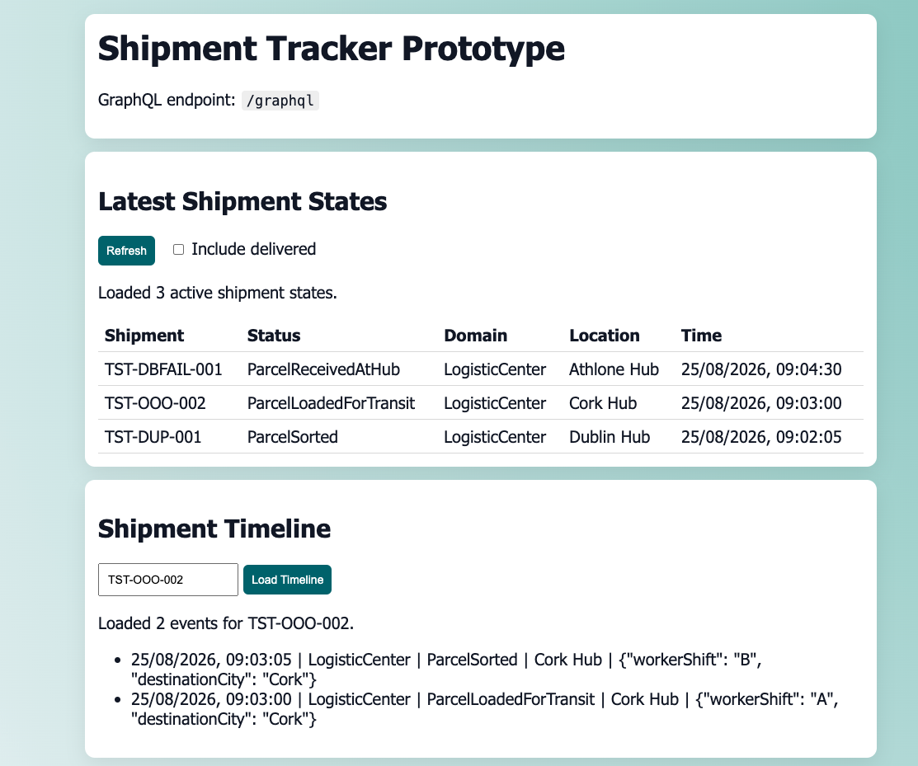
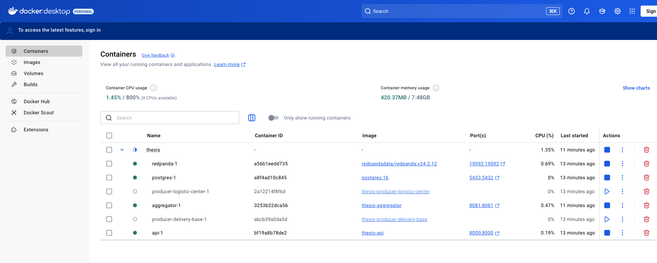
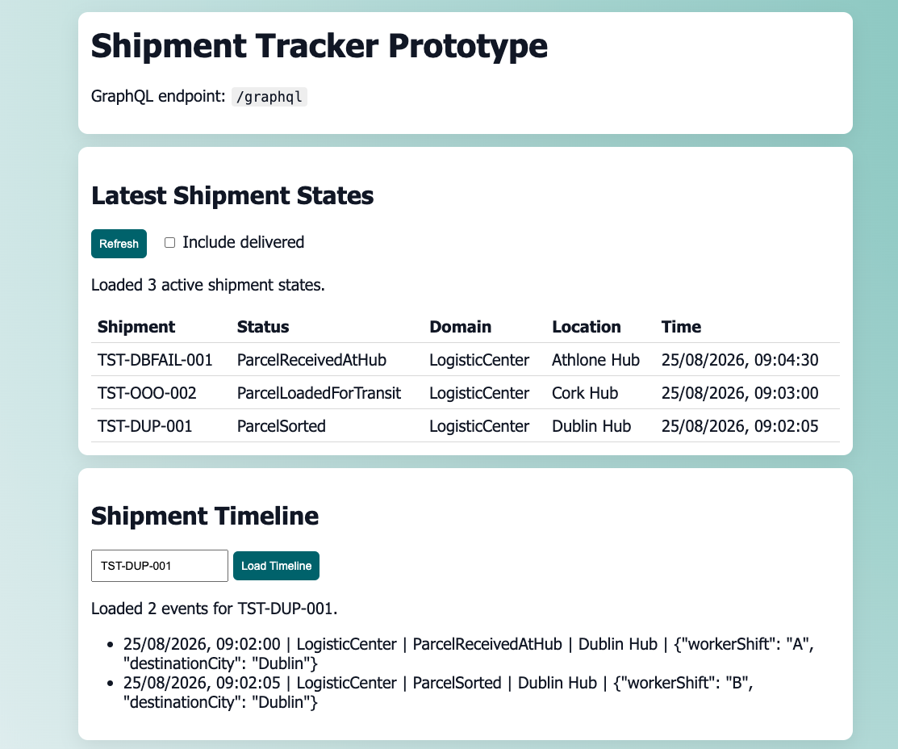

Stage | Committed offset | Log end | Lag | Restart count
Before valid test | 13 | 13 | 0 | 9
During DB failure | 13 | 14 | 1 | 11 and increasing
After recovery | 14 | 14 | 0 | 16

Externally enforced Azure for Students restriction that forbids creation of the protocol-required Azure Front Door resource. Because Front Door is part of the frozen G1/G2 design, substituting another routing mechanism would materially change the experiment.

Multi-region active-passive and active-active configurations were designed but not experimentally evaluated because the Azure for Students subscription prohibited creation of Azure Front Door, which was the frozen global-routing component. Replacing it with another service would have changed the experimental design; therefore, the regional configurations were retained as designed strategies but excluded from empirical performance claims.

